**PROJECT**

**Building a Scalable Web Application with Azure Services**

### ****1. Traffic Manager Configuration****

**Step 1: Enable Azure Disk Encryption**

**1. Navigate to the Azure Portal**

1. Open your browser and visit Azure portal.
2. Log in with your Azure credentials.

**2. Access the Virtual Machine**

1. In the Azure portal, click on **Virtual Machines** from the left-hand menu.
2. From the list of VMs, select the one you want to enable encryption for.

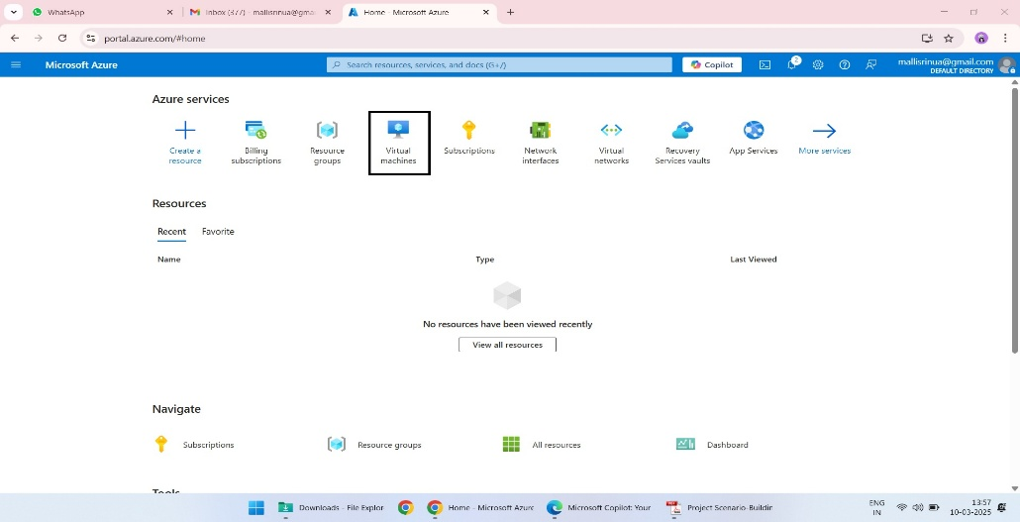

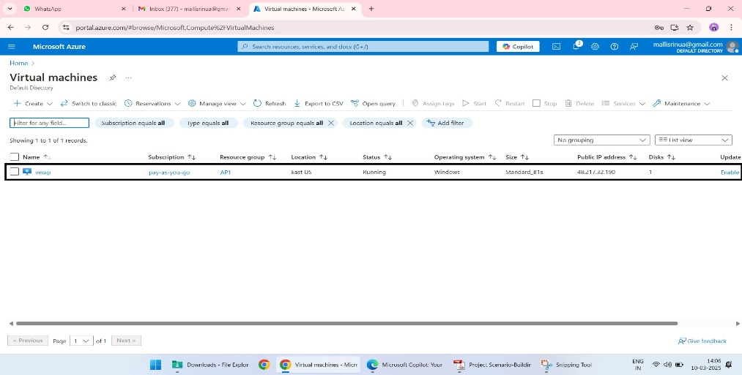

**3. Open Disk Settings**

1. In the VM overview page, under the **Settings** section (on the left panel), click on **Disks**.
2. You’ll see a list of disks (OS Disk and Data Disks) associated with the VM.

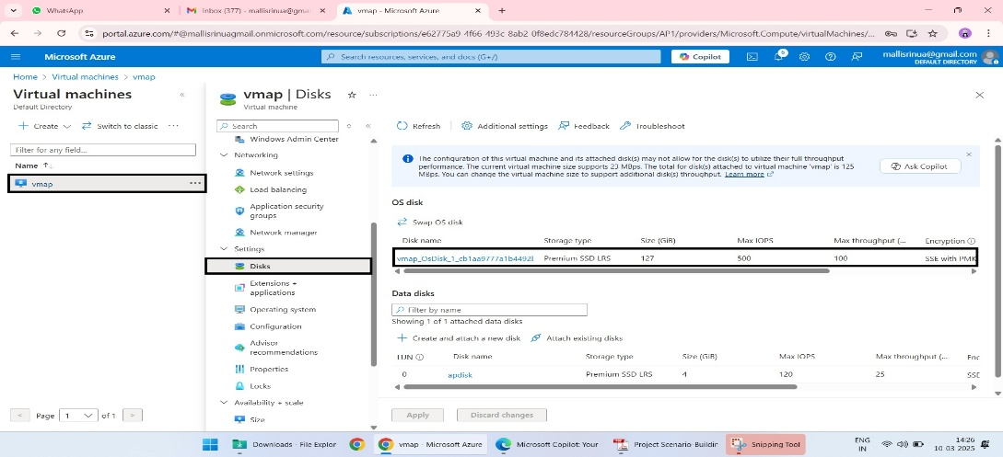

**4. Enable Disk Encryption**

1. In the top menu of the **Disks** blade, click on **Encryption**.
2. You’ll see the following options to configure:
   * **Encryption at-rest with platform-managed keys (default)**
   * **Encryption at-rest with customer-managed keys**
3. Choose the encryption type based on your needs.
   * select **Customer-managed keys**.

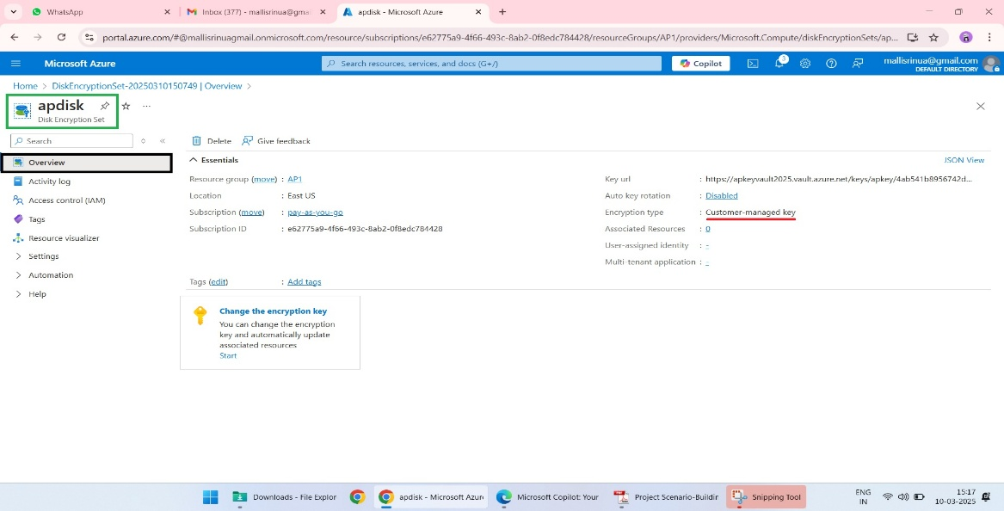

**5. Configure Customer-Managed Keys (Optional)**

1. If you selected **Customer-managed keys**, you’ll need to integrate with Azure Key Vault:
   * Navigate to **Azure Key Vault** from the portal search bar.
   * Create a new Key Vault by clicking **+ Create**.

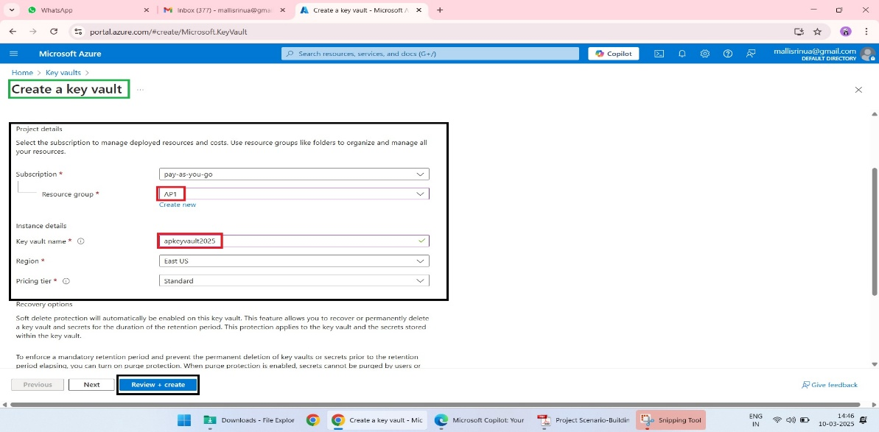

* + After creating the Key Vault, go to **Keys** under the Key Vault settings and click **+ Generate/Import**.
  + Create a new key that will be used for disk encryption.

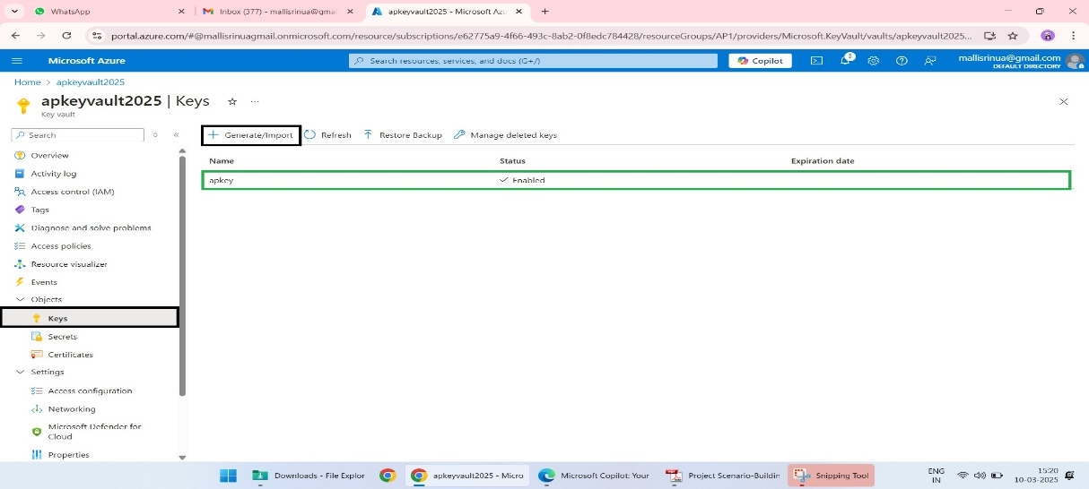

1. Link the Key Vault to your VM disk encryption settings:
   * Return to the **Disks → Encryption** page for your VM.
   * Select the Key Vault and the key you created.

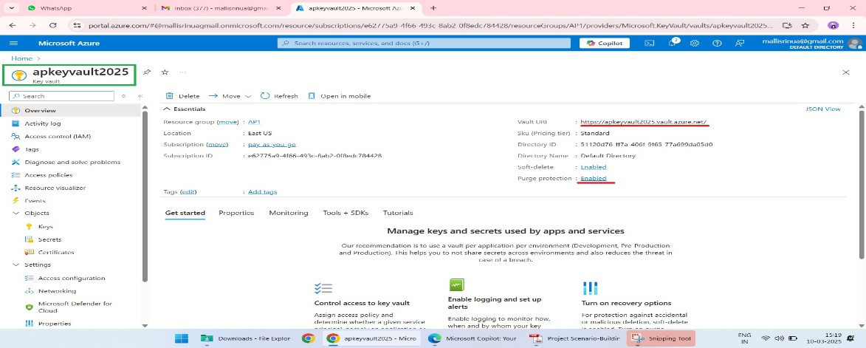

**6. Apply Encryption**

1. After configuring the encryption settings, click **Save**.
2. Azure will begin the encryption process. This might take a few minutes to complete.

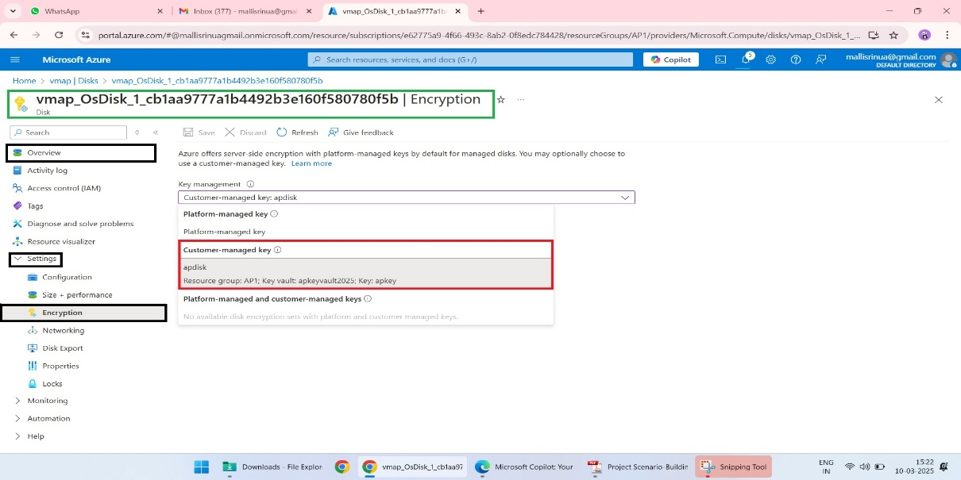

**7. Verify Encryption Status**

1. Once the process is complete, go back to the **Disks** blade.

2. Check the **Encryption** column to confirm that the disk encryption status

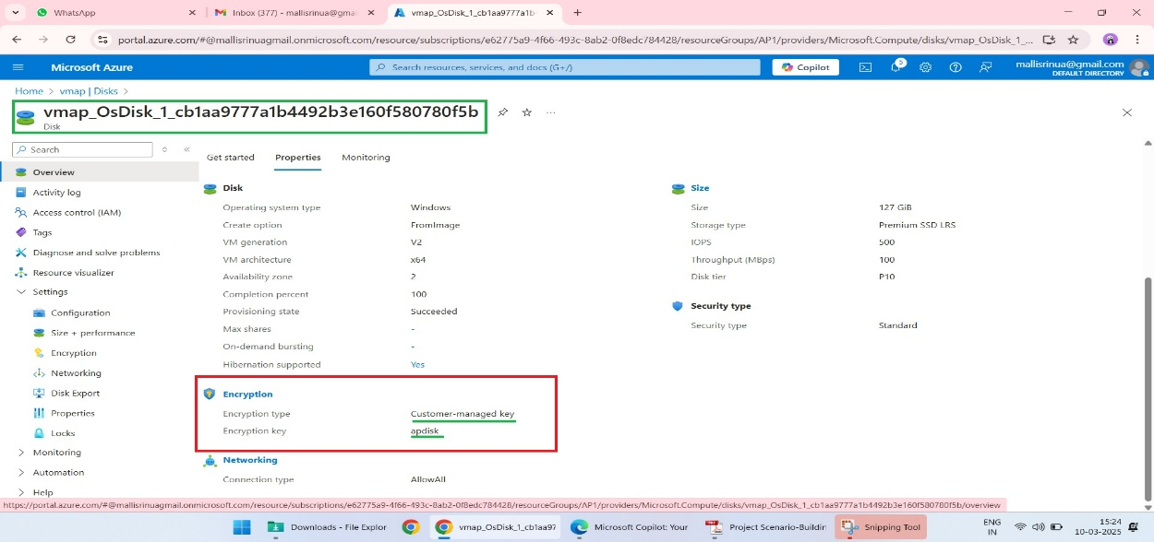

#### ****Step 2. Create Traffic Manager Profile****

1. In the Azure portal, search for **Traffic Manager profiles**.
2. Click **+ Create**.

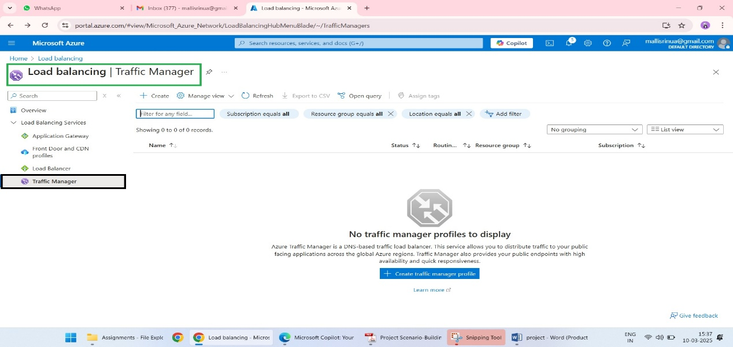

1. Fill in:
   * **Name**: Enter a unique name.
   * **Routing Method**: Choose "Performance" for fast response times.
   * **Resource Group**: Select or create a new one.
2. Click **Review + Create** → **Create**.

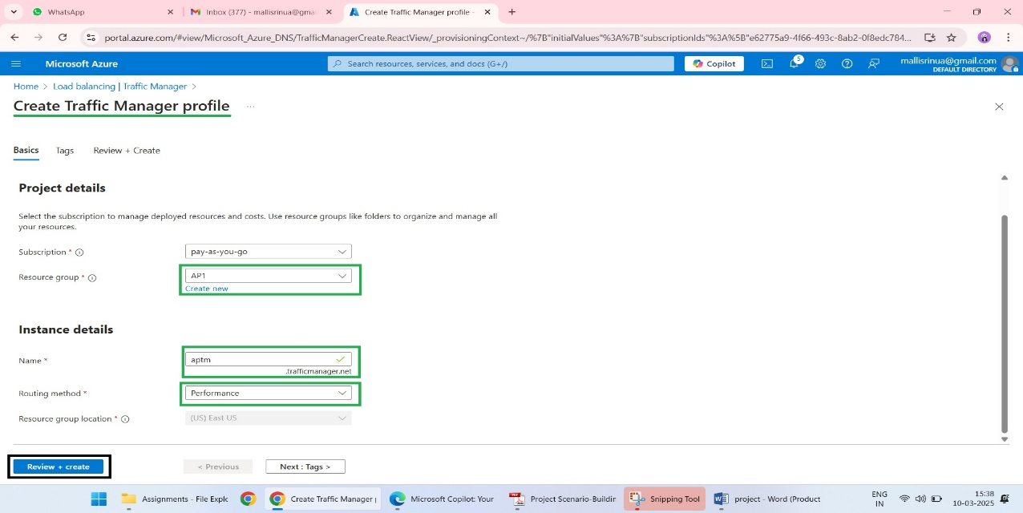

#### ****Step 3. Add Endpoints****

1. Go to your Traffic Manager profile.
2. Under **Settings**, select **Endpoints**.
3. Click **+ Add**.
4. Fill in:
   * **Name**: Give a name to the endpoint.
   * **Type**: Choose "Azure endpoint".
   * **Target Resource**: Select the web application in a specific region.

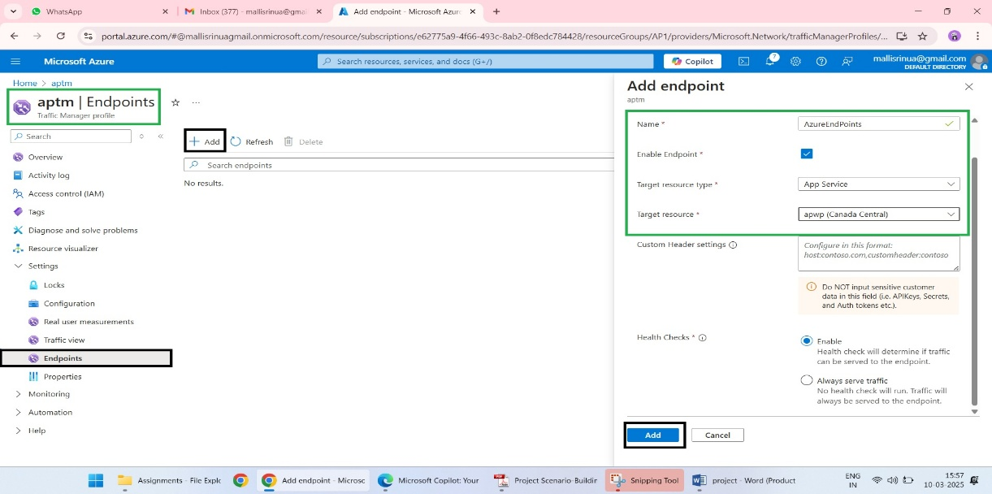

#### ****Step 4. DNS-Based Load Balancing****

1. Return to your Traffic Manager profile settings.
2. Make sure your chosen **Routing Method** (like "Performance") matches your needs.
3. Use the Traffic Manager **DNS Name** (visible in the overview) to update your domain's DNS records.

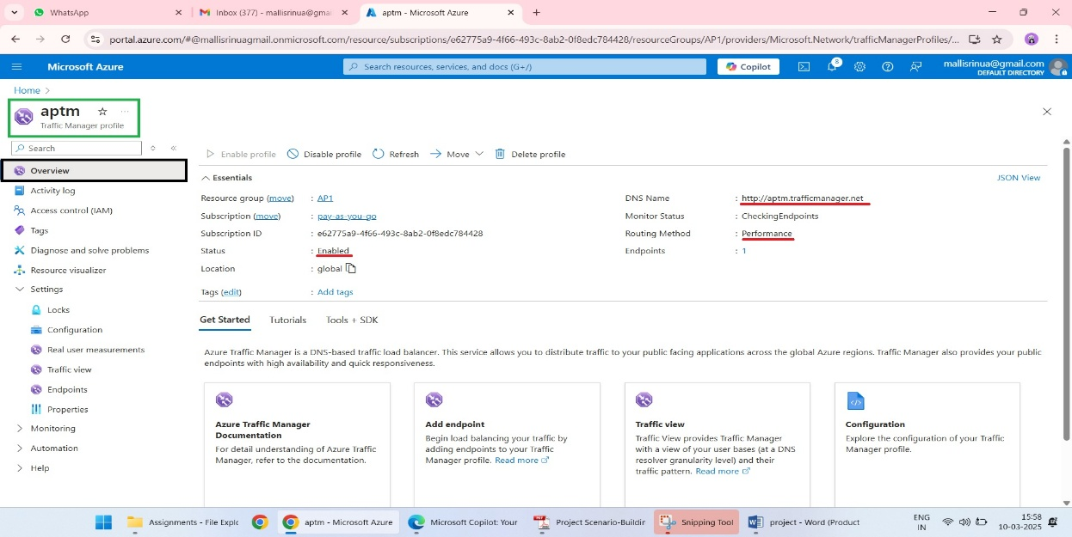

### Step 2: Load Balancer Setup

### ****Enable Azure Backup for Virtual Machines****

#### ****1. Check Recovery Services Vault****

Azure VM Backup relies on a **Recovery Services Vault**. If you don’t already have one, you’ll need to create it first.

1. In the Azure portal, search for **Recovery Services Vaults**.
2. Click **+ Create**.
3. Fill in:
   * **Name**: Enter a unique name (e.g., "BackupVault").
   * **Subscription**: Select your subscription.
   * **Resource Group**: Select the same resource group as your VMs (e.g., AP1).
   * **Region**: Ensure it matches the region of your VMs.
4. Click **Review + Create** → **Create**.

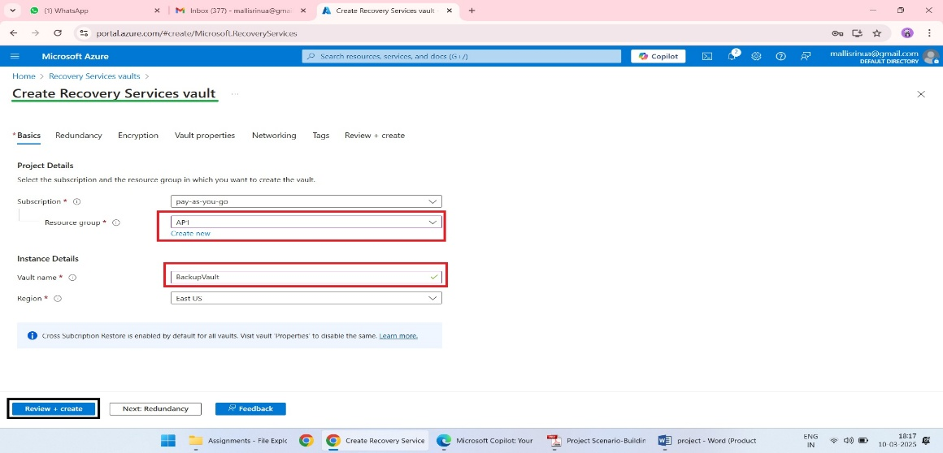

#### ****2. Configure Backup for Your VMs****

Once the Recovery Services Vault is ready, follow these steps:

1. Navigate to the **Recovery Services Vault** you just created.
2. In the vault’s menu, click **Backup**.
3. In the **Backup Goal** section:
   * Select **Azure** as the **Where is your workload running?** option.
   * Choose **Virtual machine** as the workload type.
   * Click **Continue**.

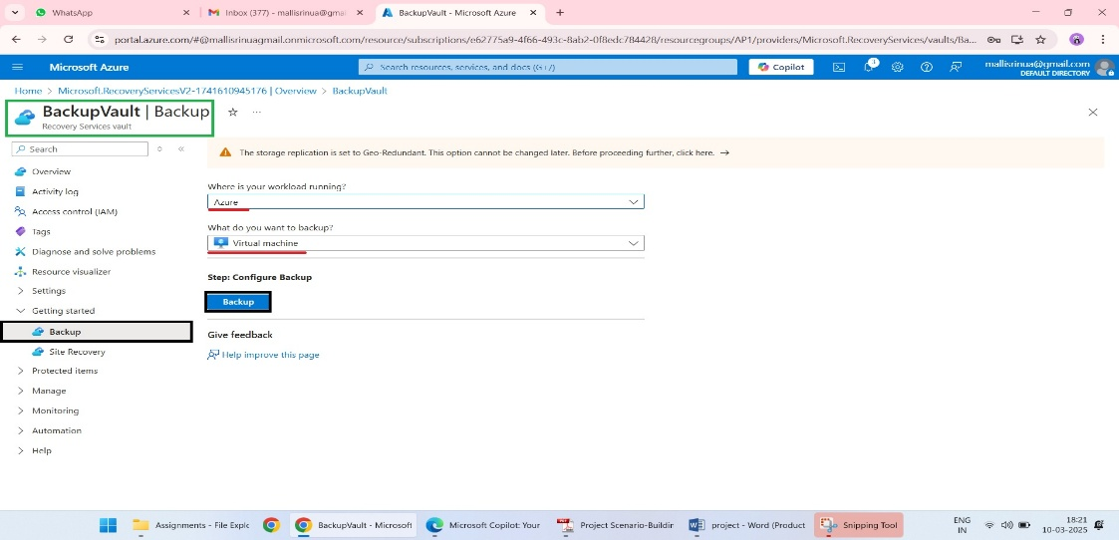

1. Under **Backup Policy**:
   * Select an existing policy, or click **+ Create** to define a new one.
   * Set backup frequency (e.g., daily) and retention (e.g., 30 days).

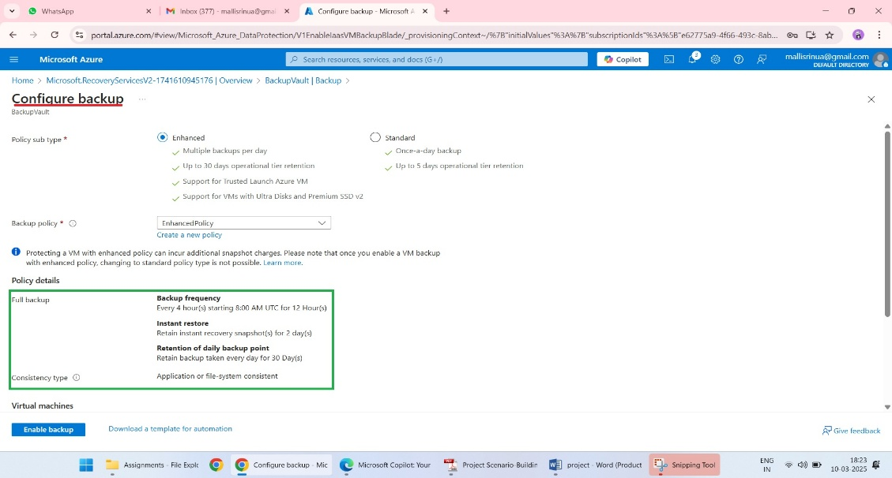

1. Under **Select Virtual Machines**:
   * Click **+ Add** and select VM1 and VM2 from the list.
2. Click **Enable Backup** to start protecting your VMs.

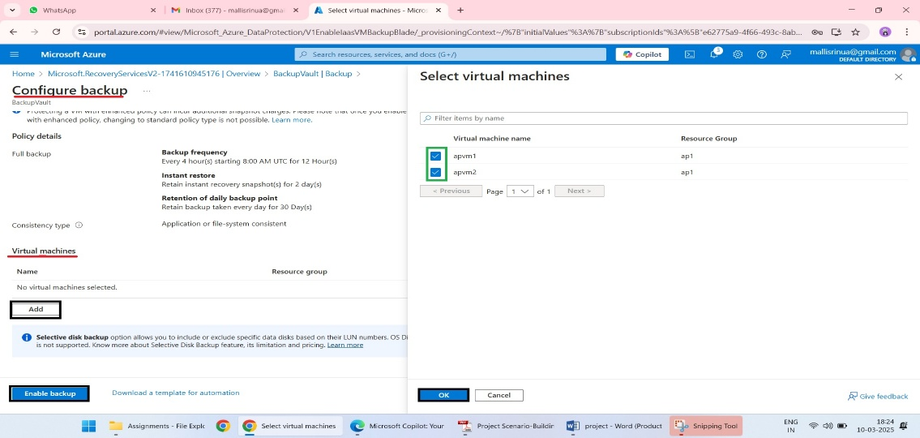

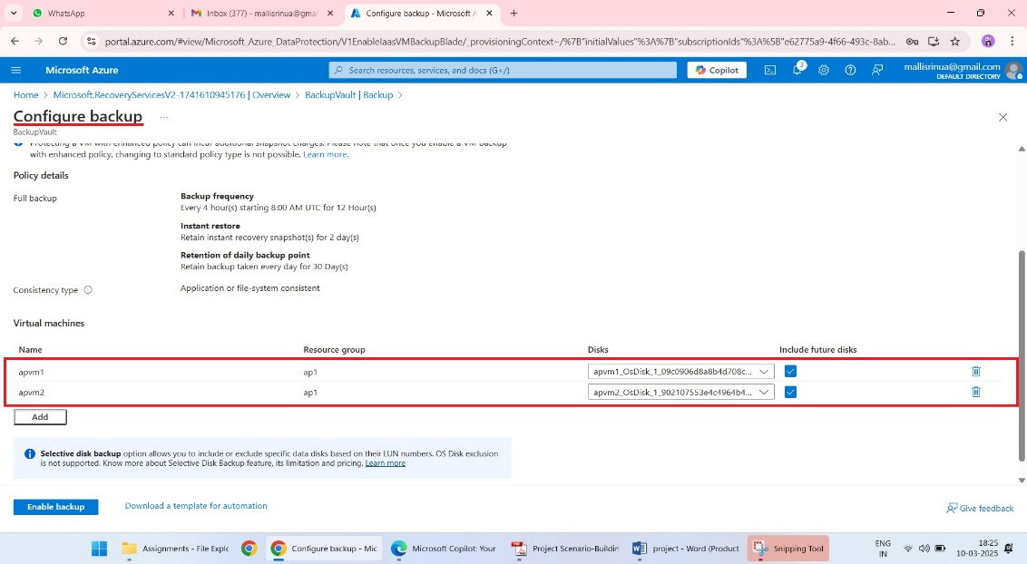

#### ****3. Verify the Backup Configuration****

1. Go back to the **Backup Items** section of the Recovery Services Vault.
2. You should see VM1 and VM2 listed with the status **Configured**.
3. To trigger a backup immediately:
   * Select the VM and click **Backup Now**.

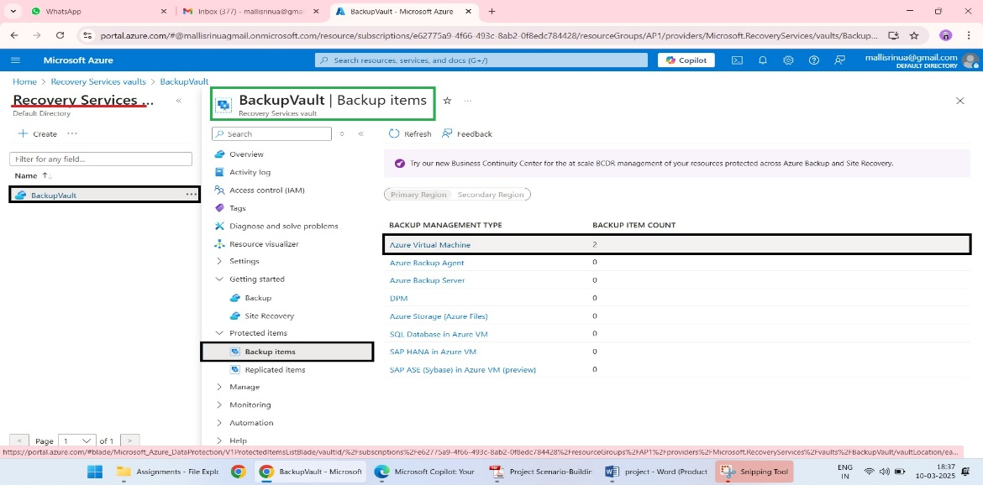

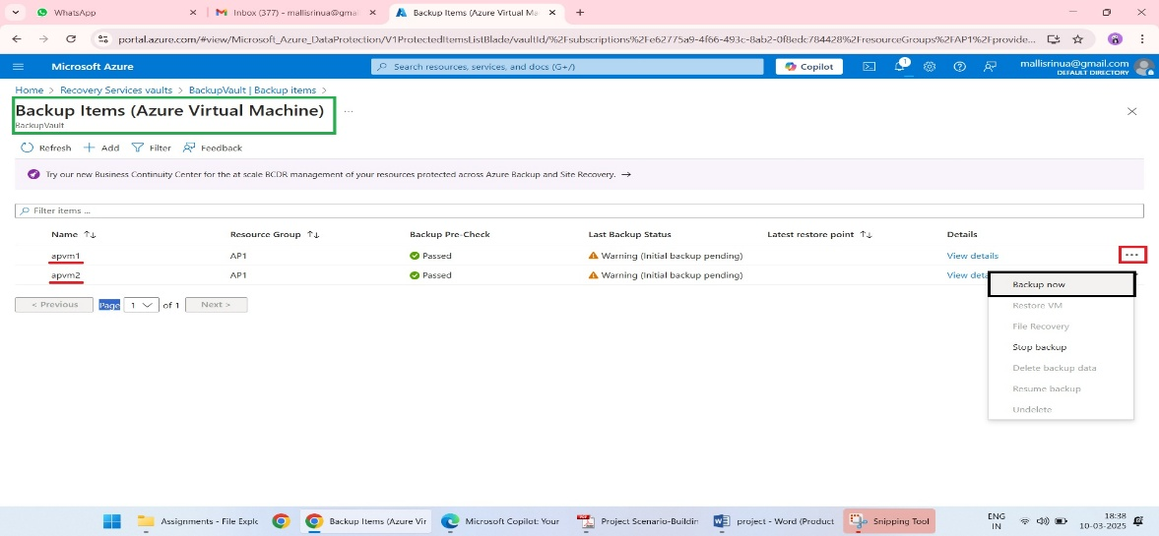

### ****2. Deploy Azure Standard Load Balancer****

1. **Navigate to Load Balancers**:
   * In the Azure portal, search for **Load Balancers**.

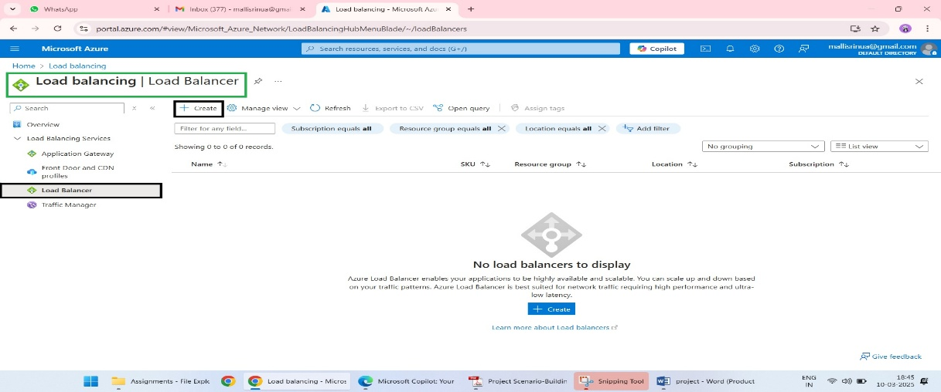

1. **Create a Standard Load Balancer**:
   * Click **+ Create**.
   * Fill in the details:
     + **Name**: Give it a name (e.g., "WebAppLoadBalancer").
     + **SKU**: Choose **Standard**.
     + **Region**: Select the region where your VMs are deployed.
     + **Resource Group**: Use the same one as your VMs (e.g., AP1).
   * Click **Review + Create** → **Create**.

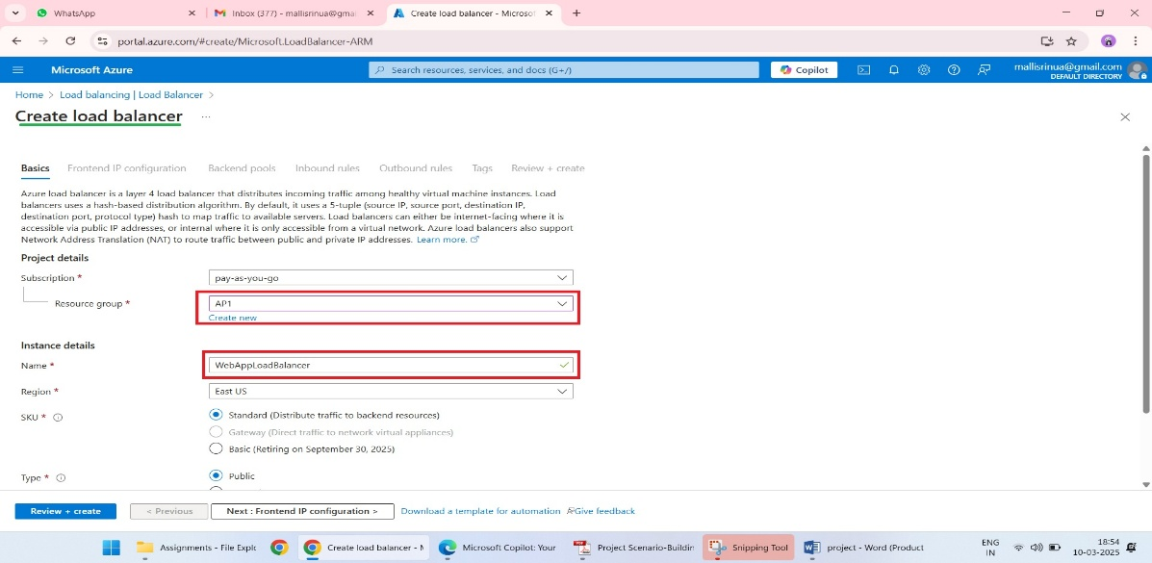

### ****3. Configure Backend Pool****

1. **Access Backend Pools**:
   * Go to your Load Balancer.
   * Under **Settings**, click **Backend Pools**.
2. **Add a Backend Pool**:
   * Click **+ Add**.

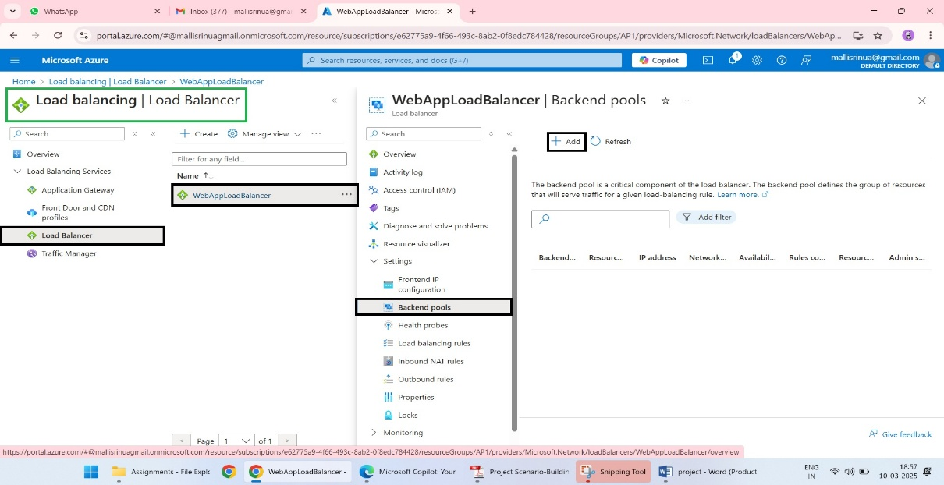

* + Name the pool (e.g., "WebBackendPool").
  + Select **Virtual Network** and choose your VNet.
  + Add **VM1** and **VM2** to the backend pool.
  + Click **Save** to finalize the backend pool setup.

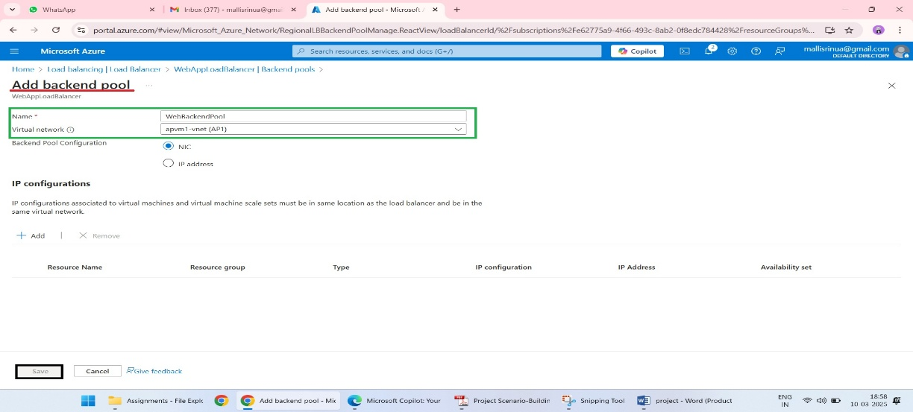

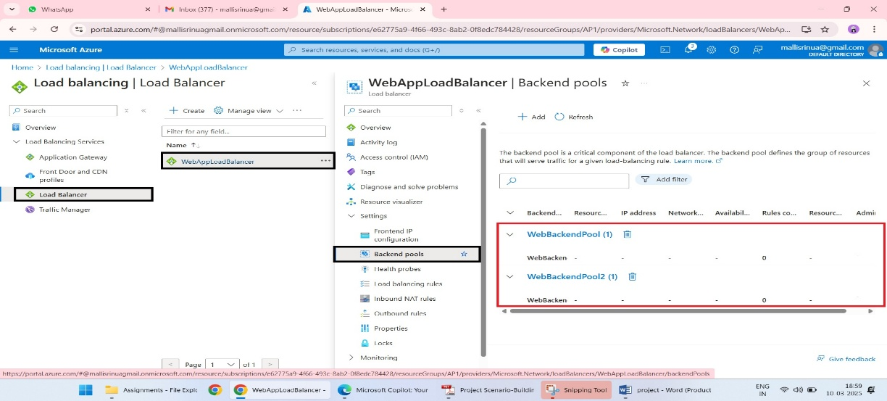

### ****4. Configure Health Probes****

1. **Go to Health Probes**:
   * Under the Load Balancer’s **Settings**, select **Health Probes**.

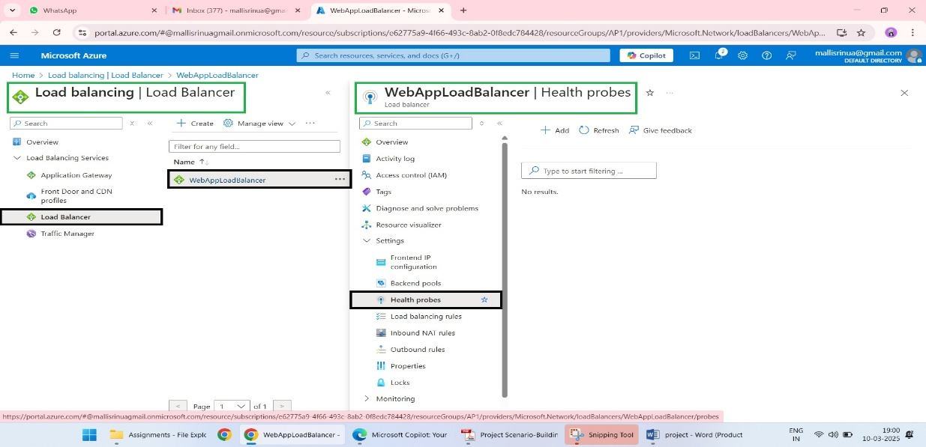

1. **Create a Health Probe**:
   * Click **+ Add** and fill in:
     + **Name**: Enter a name (e.g., "WebHealthProbe").
     + **Protocol**: Choose HTTP.
     + **Port**: Specify the port (e.g., 80 for HTTP).
     + **Interval**: Set the time between checks (e.g., 5 seconds).
     + **Unhealthy Threshold**: Set how many failed attempts mark a VM as unhealthy.
   * Click **OK** to save the health probe.

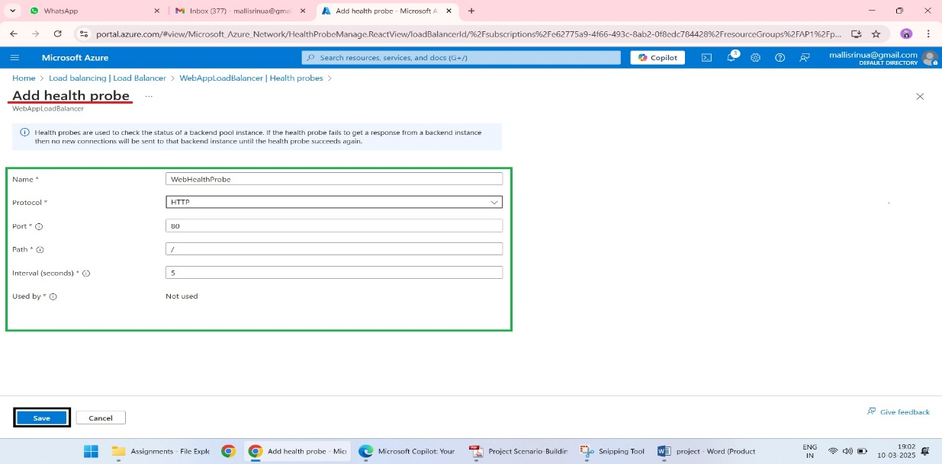

### ****5. Enable Sticky Sessions****

1. **Configure Load Balancing Rules**:
   * Go to **Settings** → **Load Balancing Rules**.
   * Click **+ Add**.

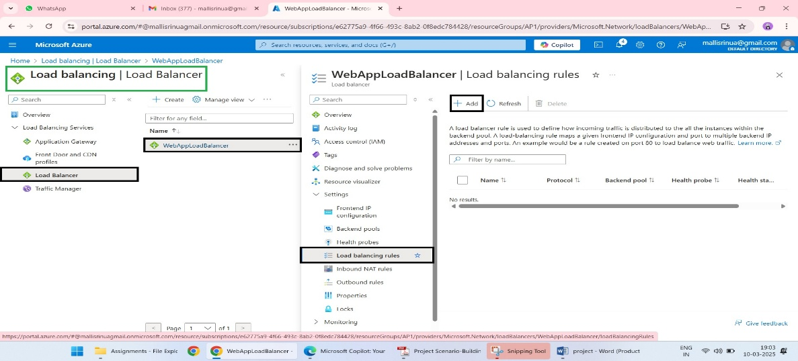

1. **Set Sticky Sessions**:
   * Fill in the details:
     + **Frontend IP Configuration**: Select your Load Balancer’s frontend IP.
     + **Backend Pool**: Select the backend pool created earlier.
     + **Session Persistence**: Choose **Client IP** to enable sticky sessions.
   * Configure other fields as needed (e.g., port 80, protocol HTTP).
   * Click **OK** or **Save** to finalize the setup.

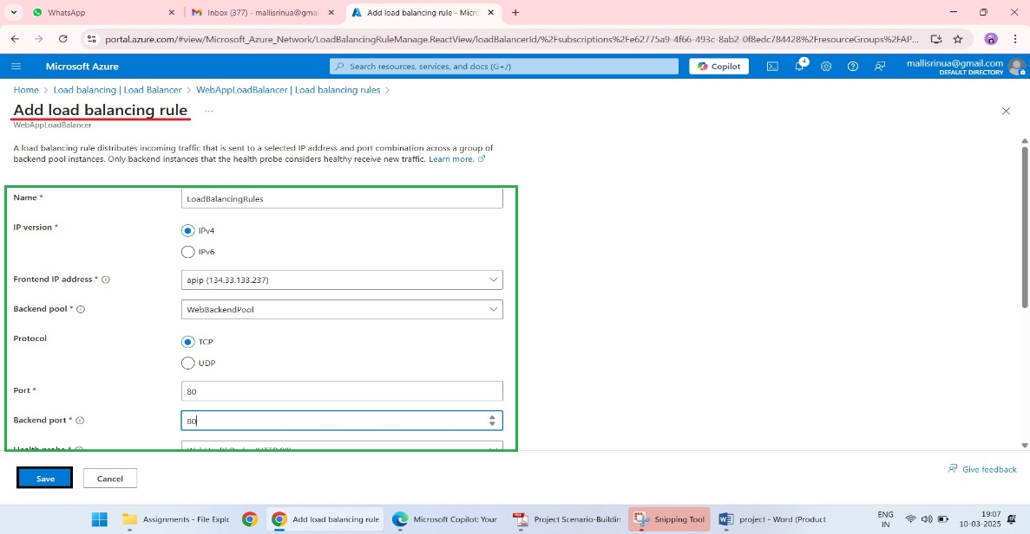

**Step 3: Virtual Machines (VMs):**

1. **Azure Private DNS Implementation**

**1.Create a Private DNS Zone:**

* In the Azure portal, search for Private DNS zones.
* Click + Create.

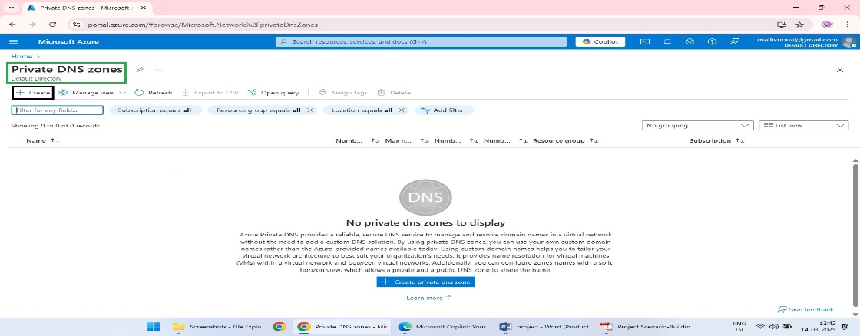

* Fill in the details:
* Name: e.g., mylocalapp.
* Resource Group: Choose the same one as your VMs (e.g., AP1).

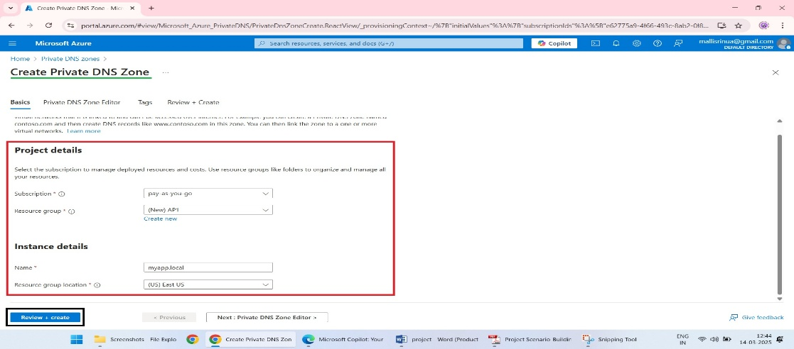

* Click Review + Create → Create.

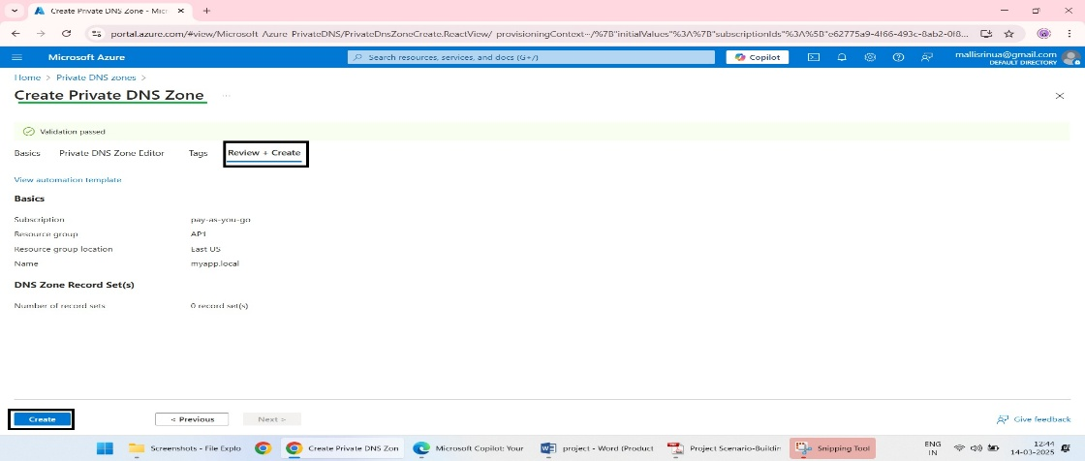

**2.Link the DNS Zone to Your Virtual Network:**

* Go to the newly created Private DNS Zone.
* Under Settings, click Virtual Network Links → + Add.

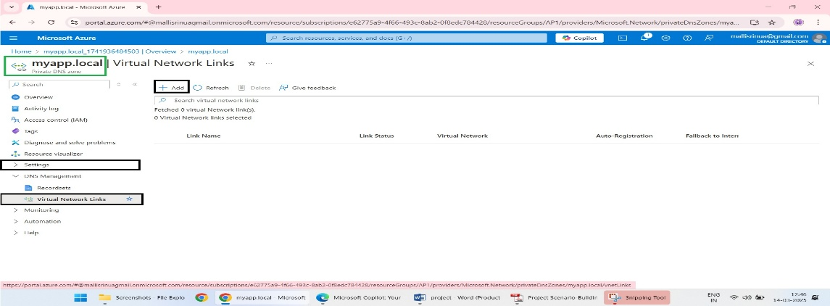

* Name the link (e.g. Mydnslink).
* Select your Virtual Network (VNet) and enable Auto-Registration to automatically add new VMs to the DNS zone.
* Click OK.

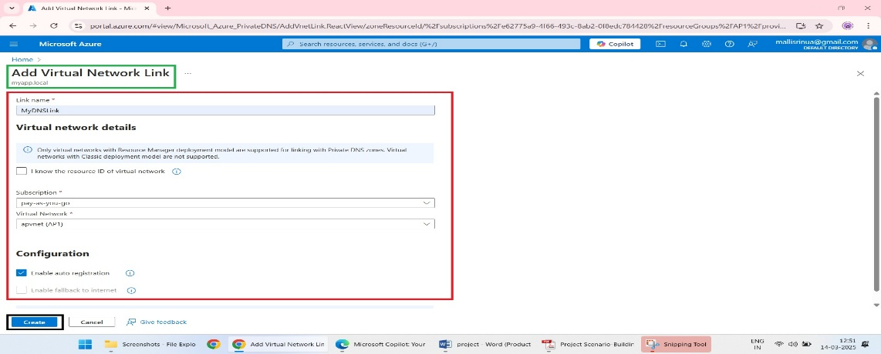

1. **Deploy Windows Server VMs:**

**1.Create the Virtual Machines:**

* In the Azure portal, search for Virtual Machines.
* Click + Create → Azure Virtual Machine.

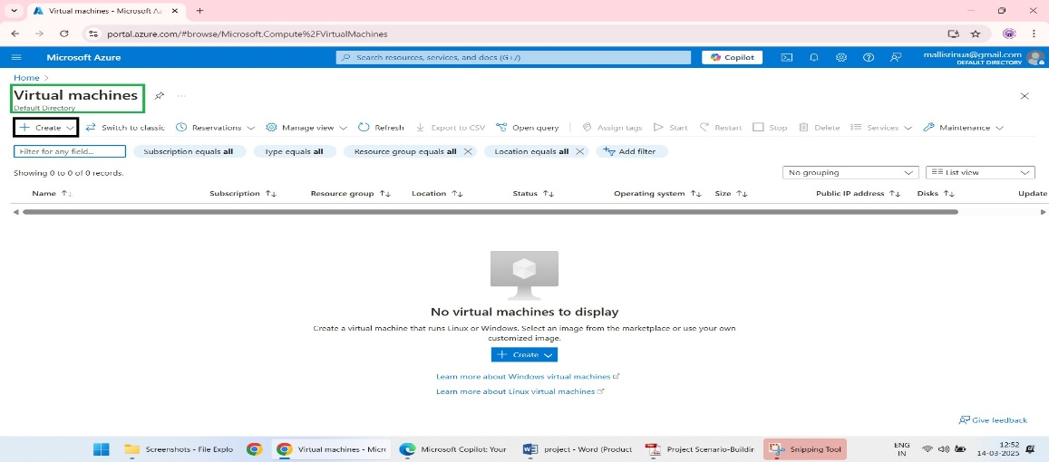

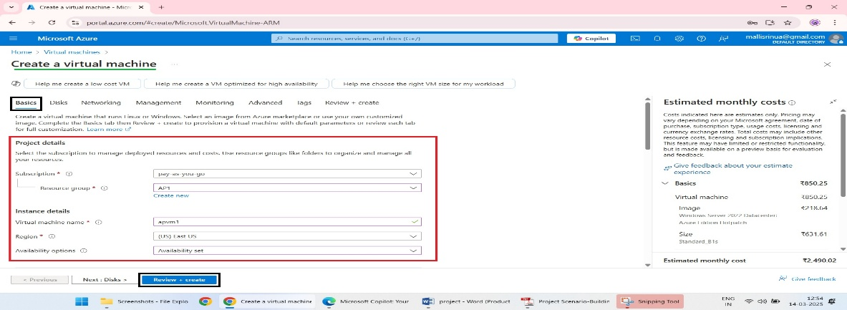

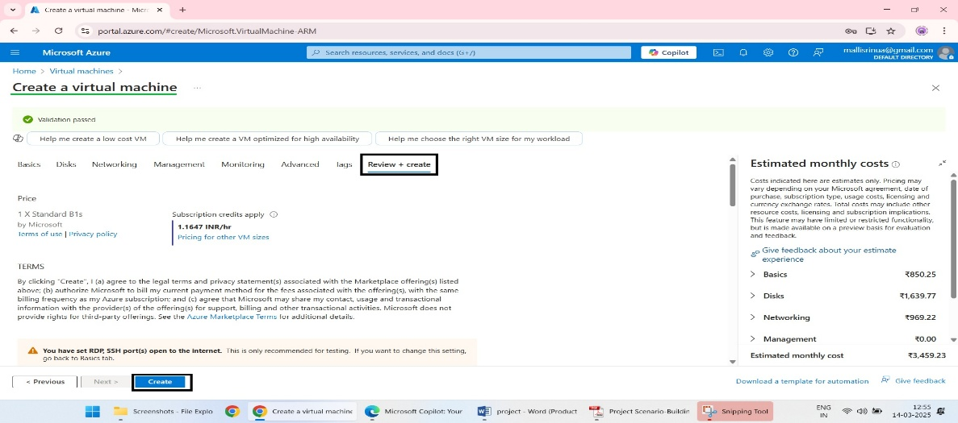

* Repeat the Above Steps for the Second VM (VM2):

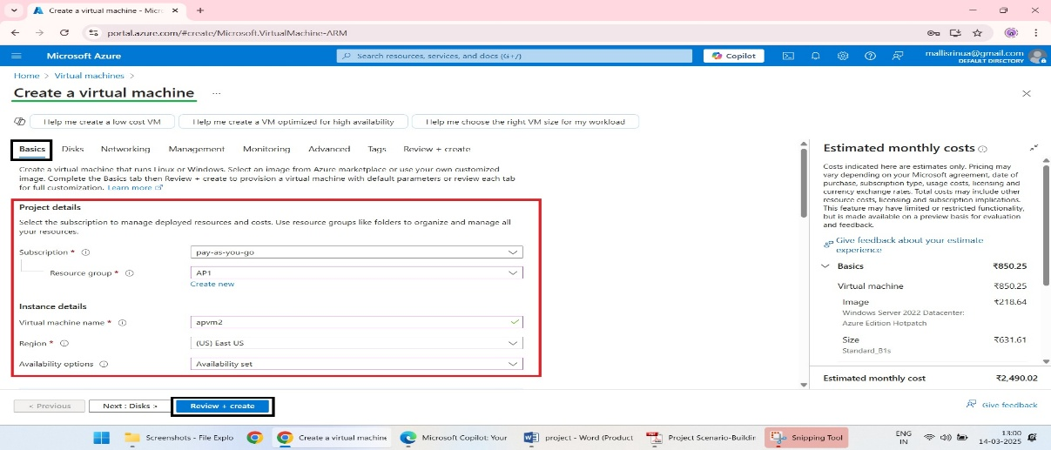

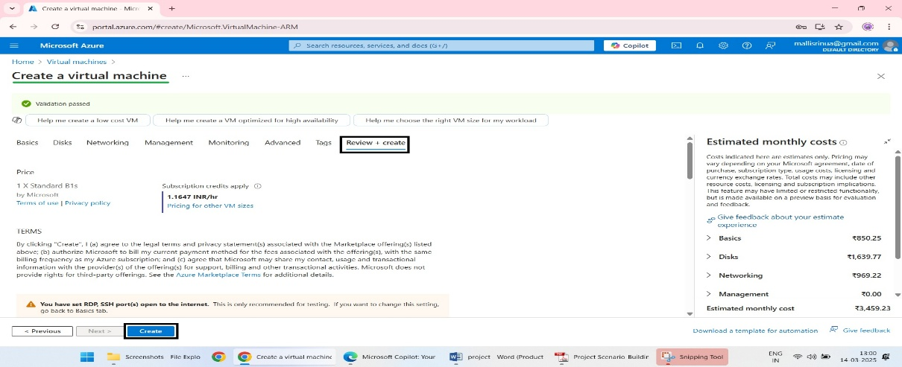

1. **IIS Installation and Configuration:**

**1.Connect to Each VM:**

* After deployment, click on VM1 in the Azure portal.
* Use Remote Desktop (RDP) on your local machine to connect to the VM.
* 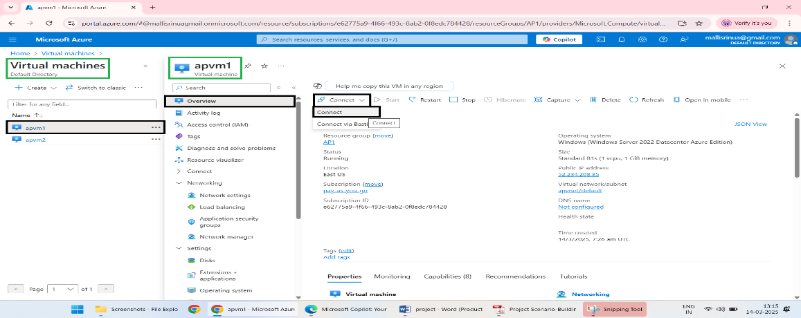
* Enter the IP address, username, and password.
* Repeat for VM2.

**2.Install IIS on Each VM**:

* Open **Server Manager.**

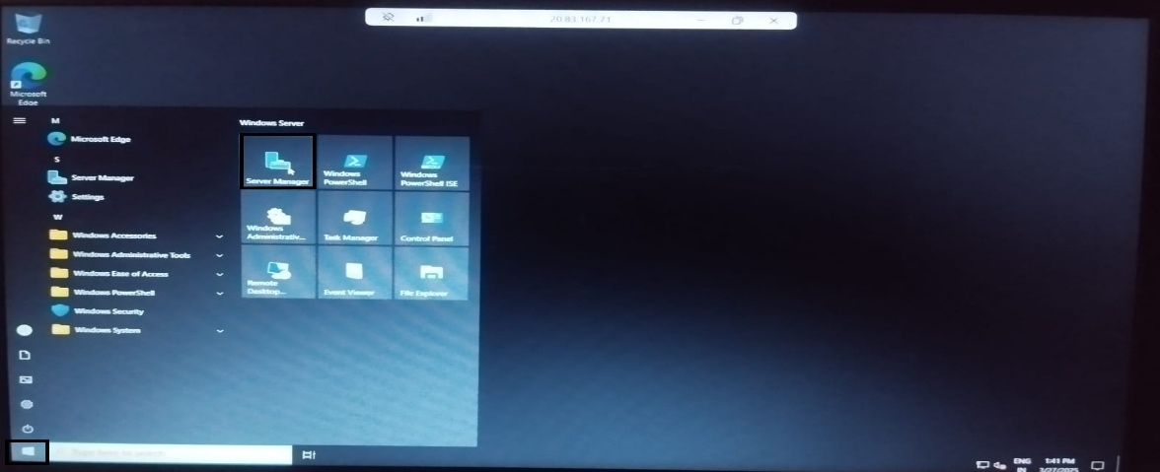

* Click **Add Roles and Features.**

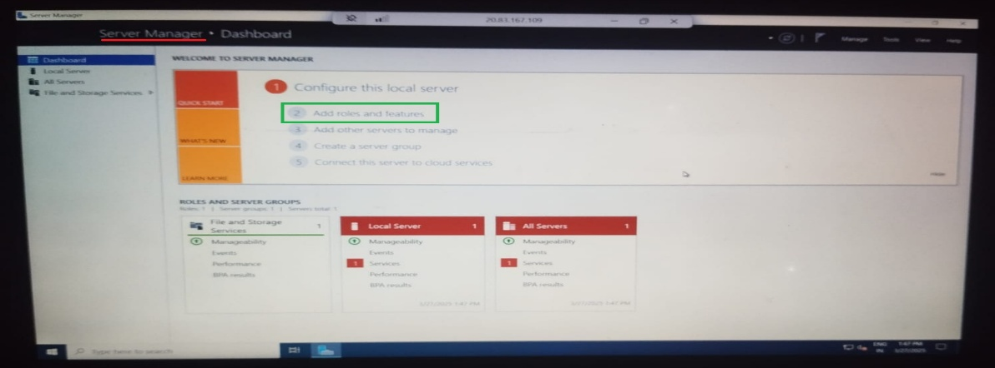

* In the wizard: Select **Web Server (IIS),** Add default features when prompted.

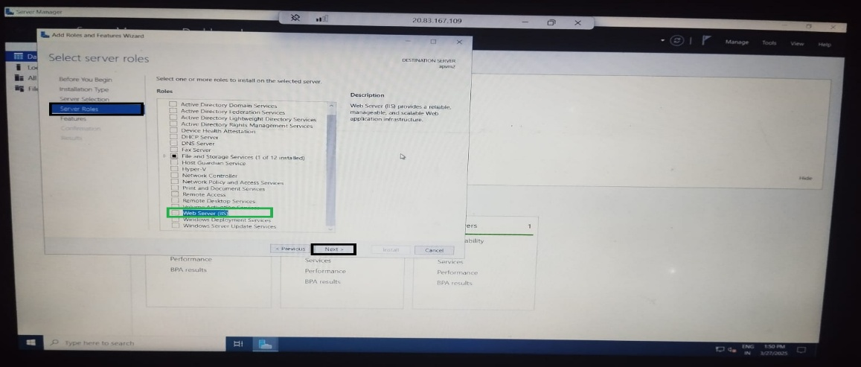

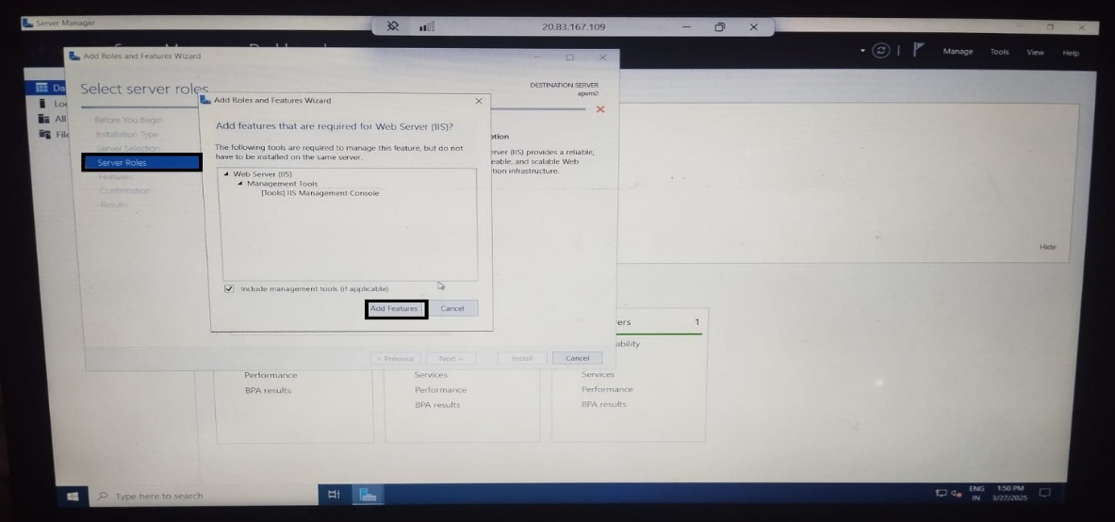

* Click **Install.**

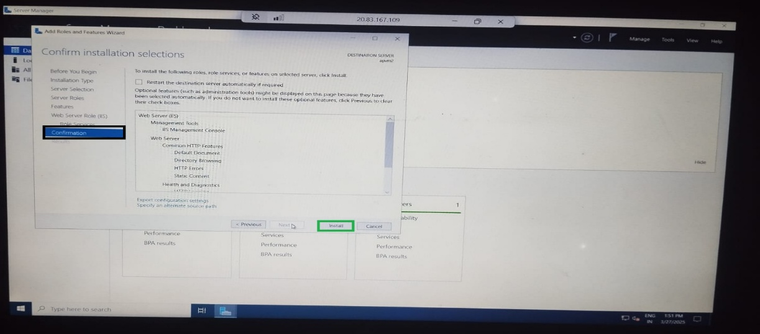

**3.Enable IIS to Serve Web Content**:

* Once IIS is installed, verify by opening a browser on the VM and navigating to <http://localhost>.
* You should see the IIS welcome page.

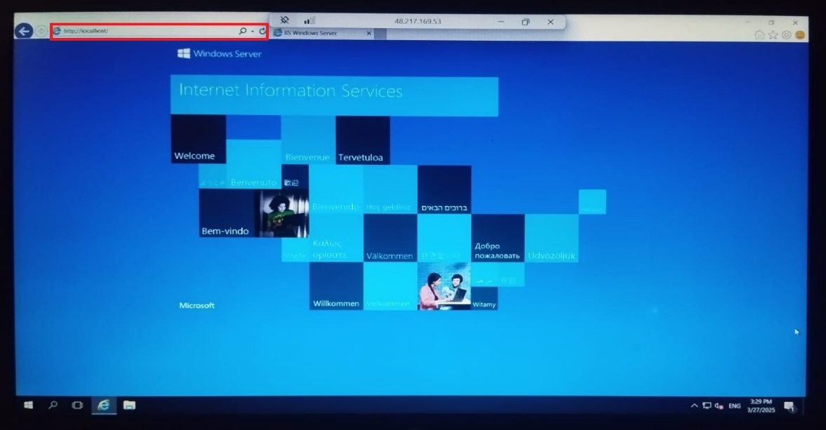

**4. Web Application Hosting on IIS**

**1.Deploy the Web Application:**

* Copy your web application files to the IIS root folder: Path C:\inetpub\wwwroot.
* Ensure your application’s files are placed correctly.

2.Configure the Application in IIS:

* Open Internet Information Services (IIS) Manager.

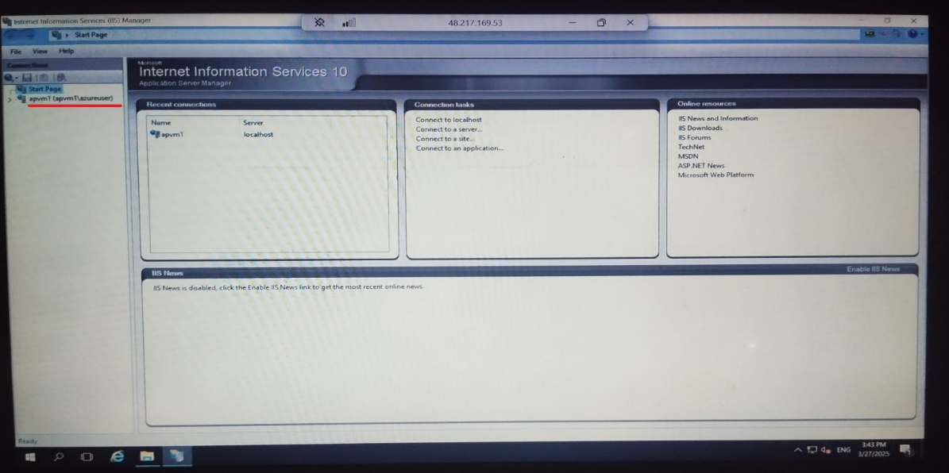

* Expand the node for your server and select Sites → Default Web Site.
* Right-click and choose Manage Website → Browse.

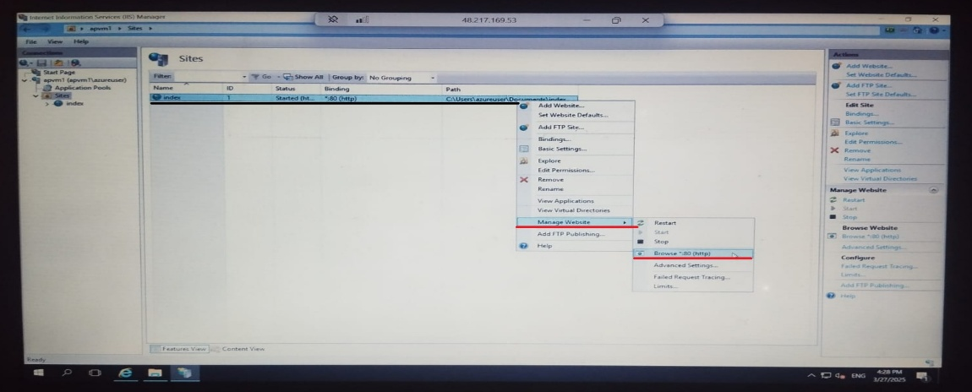

* Verify that your web application loads correctly.

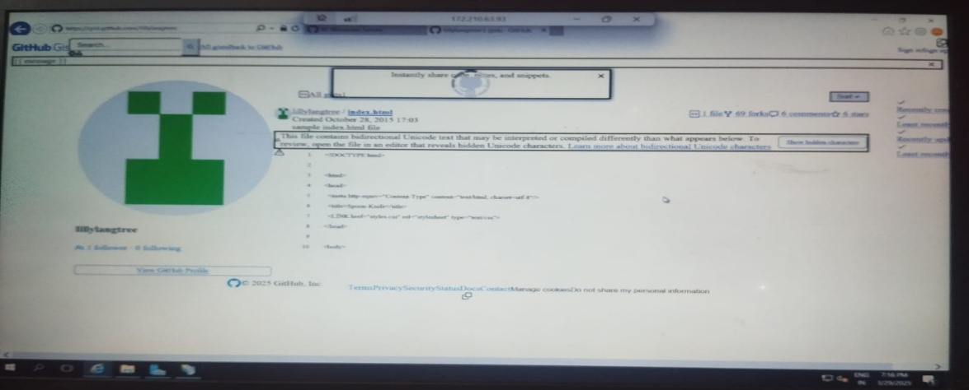

* Repeat the steps for VM2

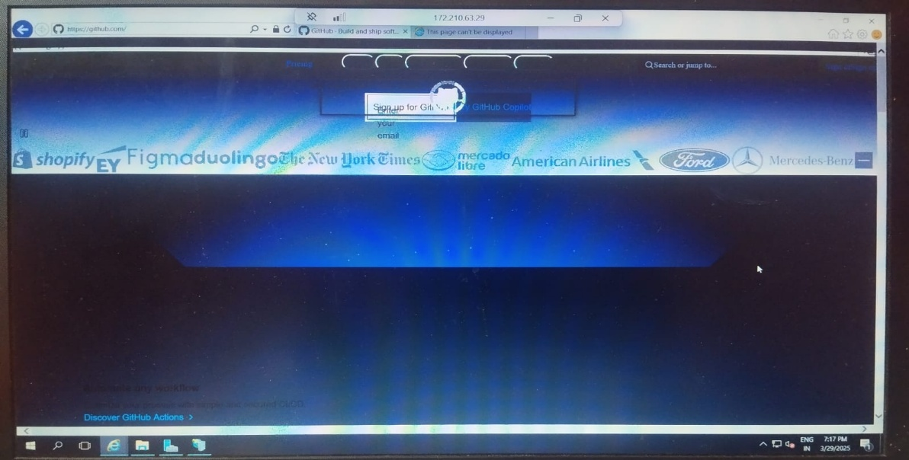

**3.Test External Access**:

* From your local machine, open a browser and navigate to the **Public IP Address** of the VM (e.g., http://<public-ip>).
* You should see your hosted web application.

**VM1 output**

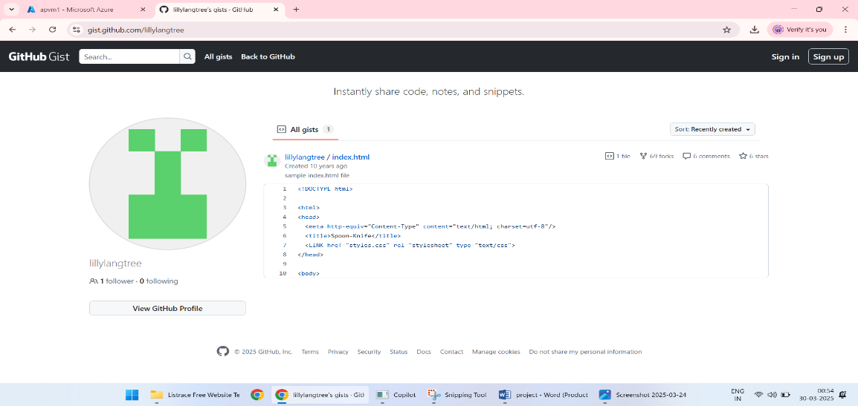

**VM2 output**

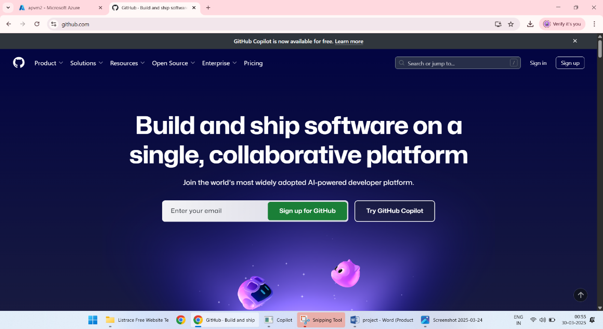

**4.Network Security Groups (NSGs):**

### ****1. NSG Creation****

1. **Go to the Azure Portal**:
   * Open the Azure portal.
   * In the search bar at the top, type **Network Security Groups** and select it from the results.
2. **Create a New NSG**:
   * Click **+ Create**.

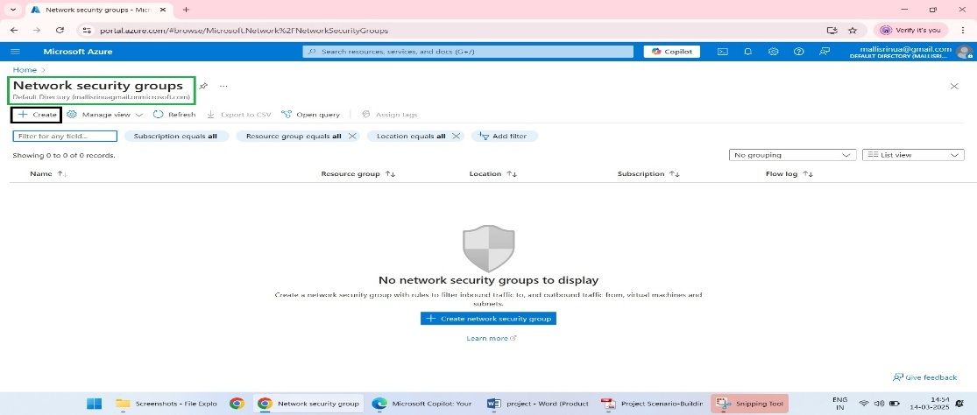

* + Fill in the following:
    - **Name**: Enter a name
    - **Resource Group**: Choose the same resource group where your VMs and subnet are located.
    - **Region**: Match the region of your VMs.
  + Click **Review + Create** → **Create**.

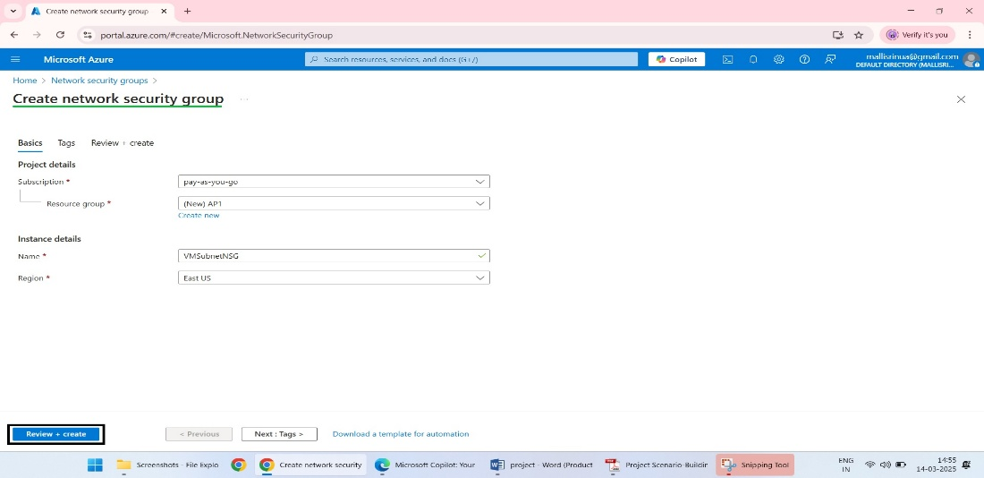

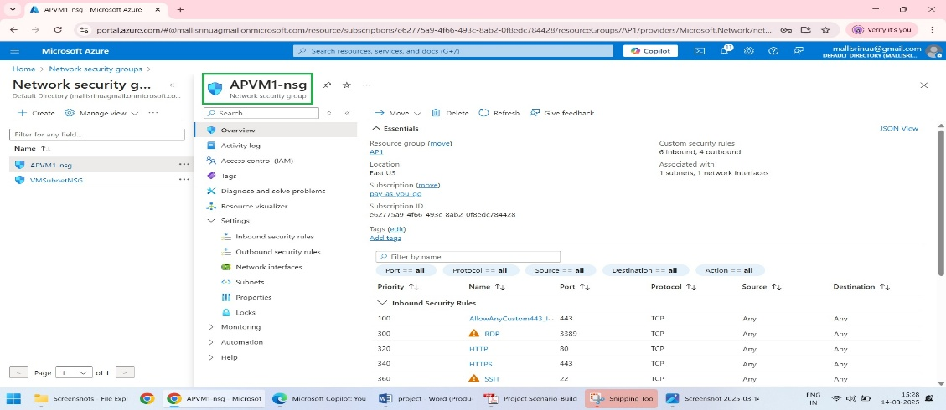

### ****2. Assign the NSG to the VM Subnet****

1. **Go to Virtual Networks**:
   * In the Azure portal, search for **Virtual Networks** and select your VNet.
2. **Access the Subnet**:
   * Under the VNet settings, click **Subnets**.
   * Select the subnet where your VMs are deployed.

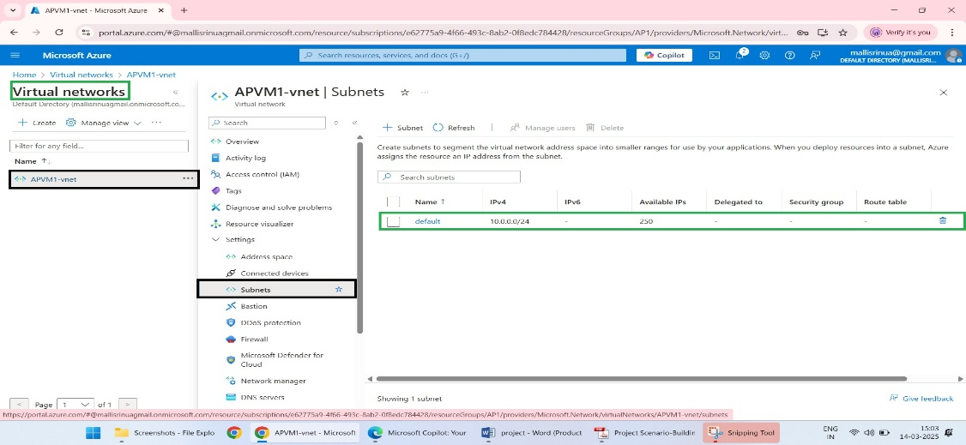

1. **Associate the NSG**:
   * In the subnet details, find the **Network security group** option.
   * Select the NSG you just created and click **Save**.

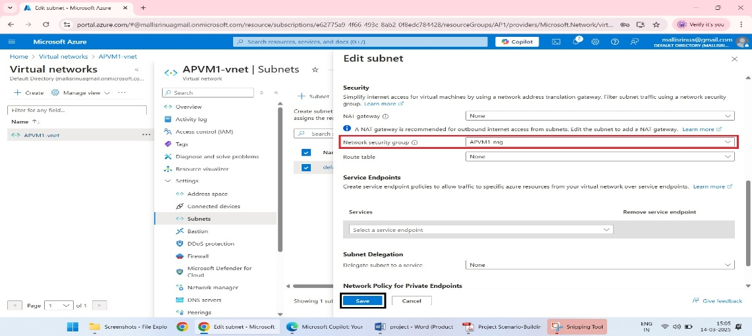

### ****3. Rule Definition****

1. **Inbound Rules**:
   * Navigate to your NSG in the Azure portal.
   * Under **Settings**, click **Inbound security rules**.

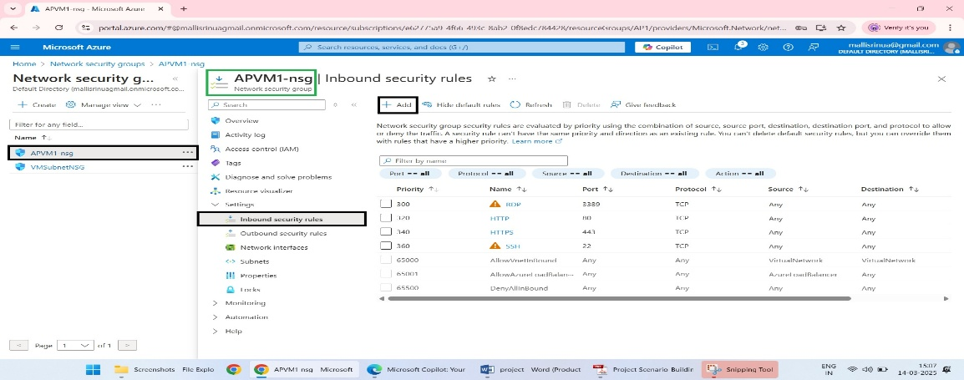

* + Click **+ Add** to define a new rule:
    - **Priority**: Enter a number (e.g., 100 for highest priority).
    - **Source**: Select **Any**, or specify a trusted IP range.
    - **Source Port Ranges**: Leave as * (all).
    - **Destination**: Select **Any** or **IP Address**, and provide the VM’s IP or subnet.
    - **Destination Port Ranges**: Enter the necessary ports (e.g., 80 for HTTP, 443 for HTTPS, or 3389 for RDP).
    - **Protocol**: Choose TCP.
    - **Action**: Allow.
  + Click **Add** to save the rule.

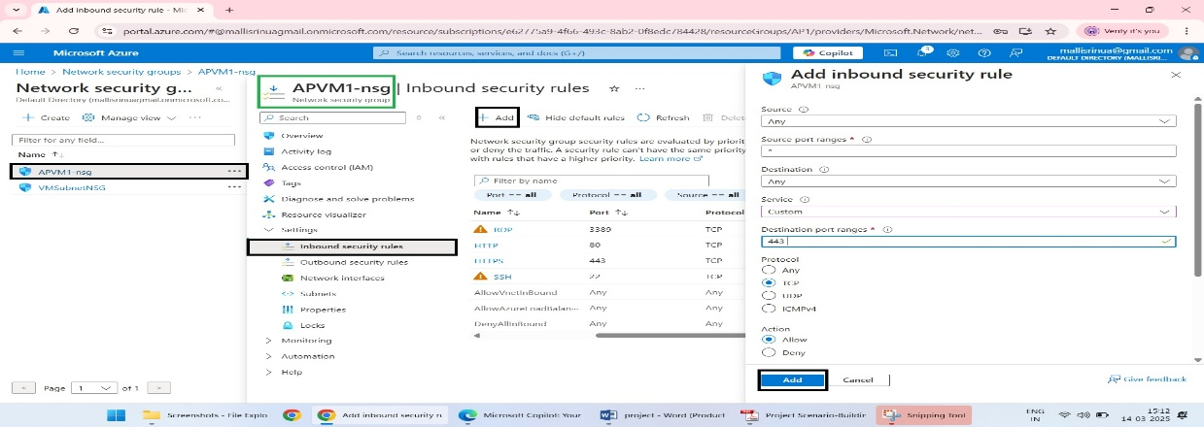

1. **Outbound Rules**:
   * Similar to inbound rules, under **Outbound security rules**, add rules to allow necessary traffic like:
     + **Priority**: e.g., 200.
     + **Destination Port Ranges**: Use 80 (for outbound HTTP) and 443 (for HTTPS).
     + **Action**: Allow.

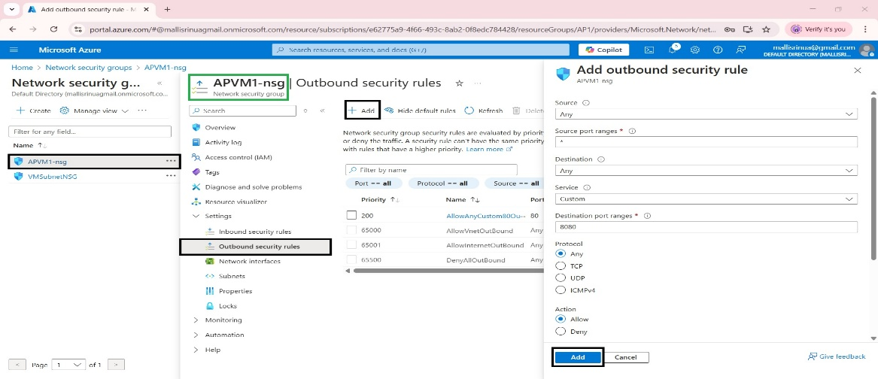

### ****4. Deny Other Inbound Traffic****

1. **Deny All Other Inbound Traffic**:
   * In **Inbound security rules**, create a new rule with:
     + **Priority**: Use a high number
     + **Source**: Any.
     + **Destination**: Any.
     + **Action**: Deny.

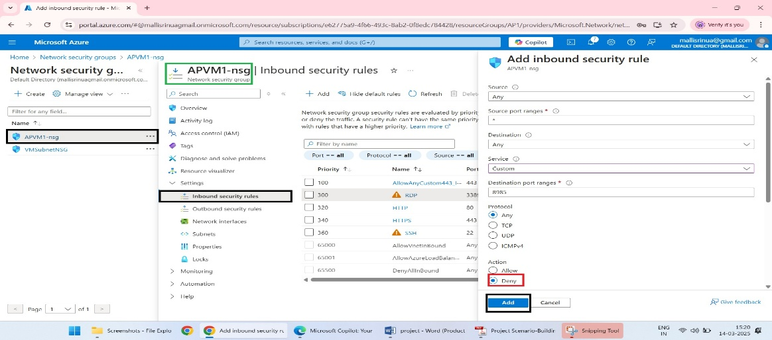

### ****5. Outbound Traffic Allowance****

1. **Allow Necessary Outbound Traffic**:
   * In **Outbound security rules**, ensure rules are in place to allow outbound traffic for the VMs to access required services, such as the internet or specific Azure resources.
   * Add rules to allow HTTP (Port 80) and HTTPS (Port 443).

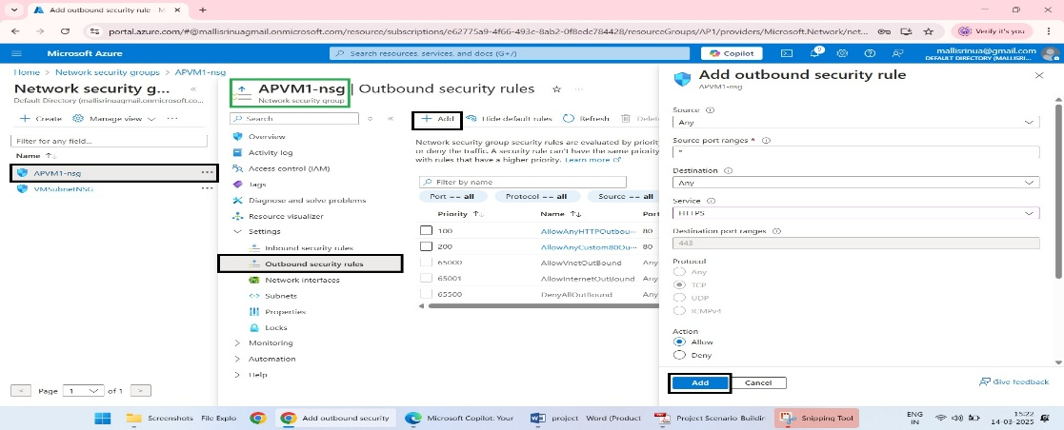

1. **Deny All Unnecessary Outbound Traffic**:
   * Add a **Deny all** rule to block outbound traffic not explicitly allowed.

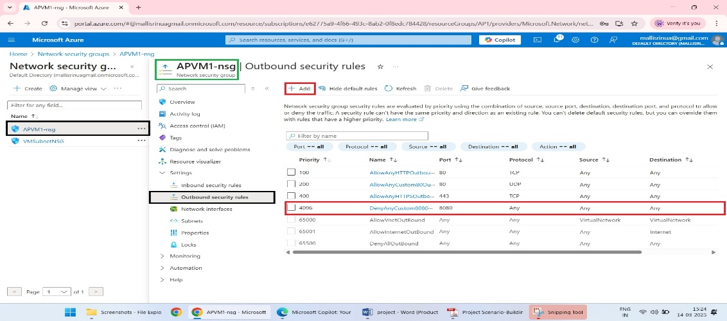

**5. VNET Peering:**

**Step 1: Create Virtual Networks (VNets)**

1. **VM-VNet**:
   * Go to the Azure Portal > **Virtual Networks** > **+ Create**.

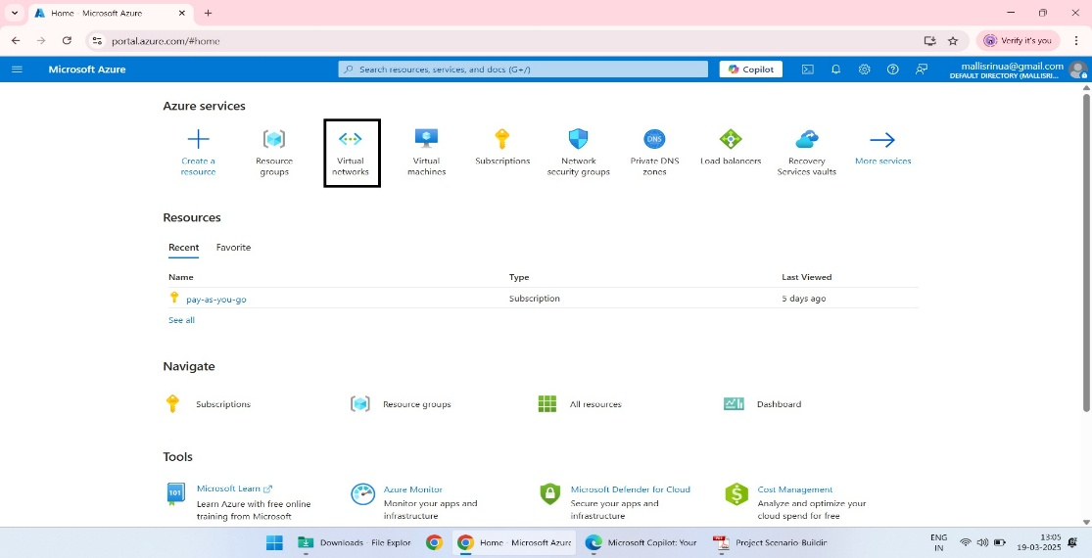

* + Configure:
    - **Name**: VM-VNet.
    - **Region**: (e.g., East US).
    - **Address Space**: 10.0.0.0/16

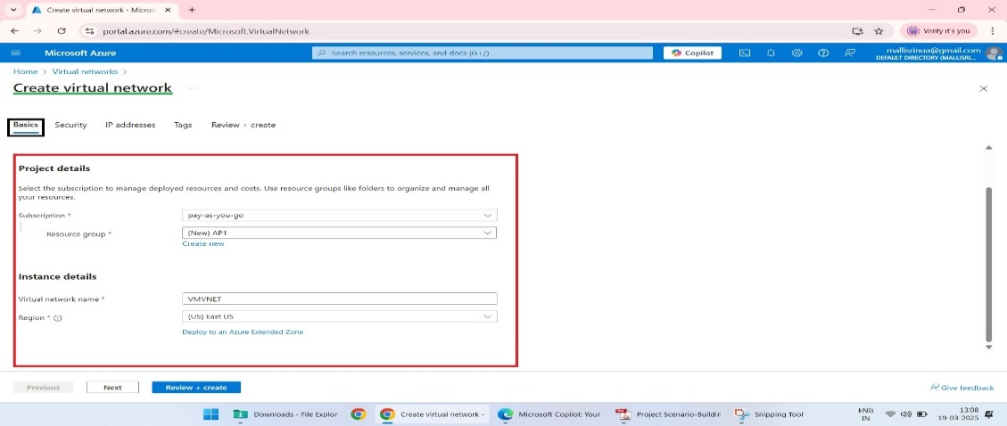

* + Add a subnet:
    - Name: VM-Subnet.
    - Address Range: 10.0.1.0/24.

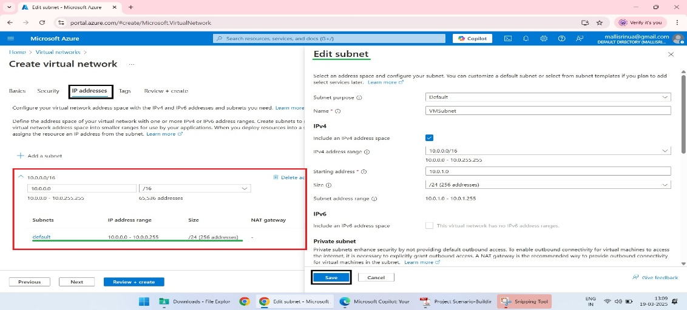

* Create the VNet.

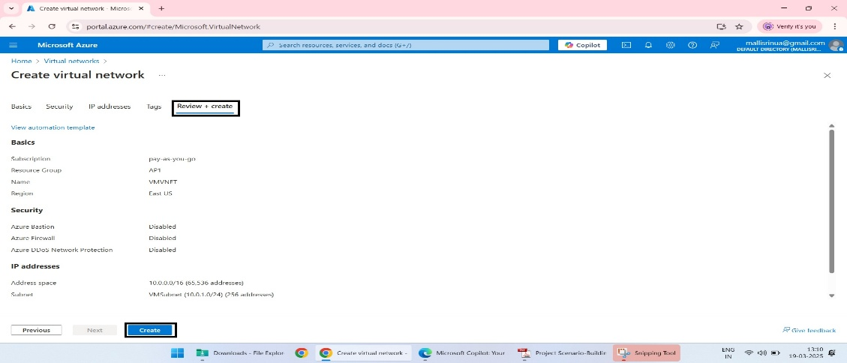

1. **Management VNet**:
   * Repeat the steps above to create a second virtual network.
   * Configure:
     + **Name**: ManagementVNet.
     + **Region**: (e.g., east US).
     + **Address Space**: 10.1.0.0/16.

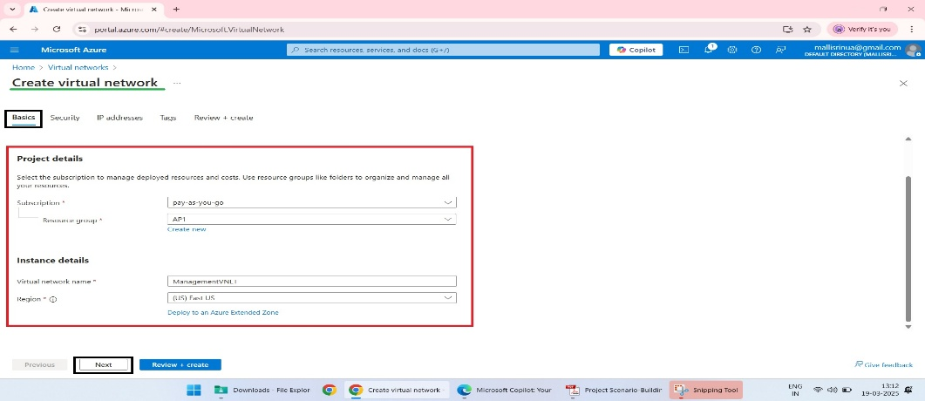

* Add a subnet:
  + - Name: Mgmt-Subnet.
    - Address Range: 10.1.1.0/24.

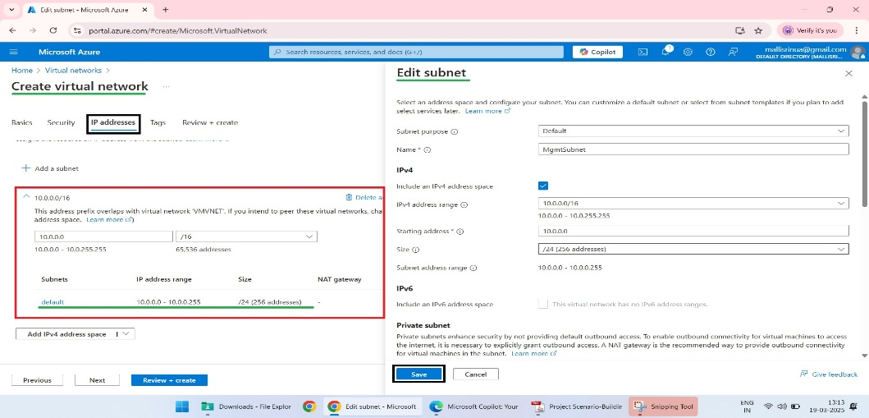

* + Create the VNet.

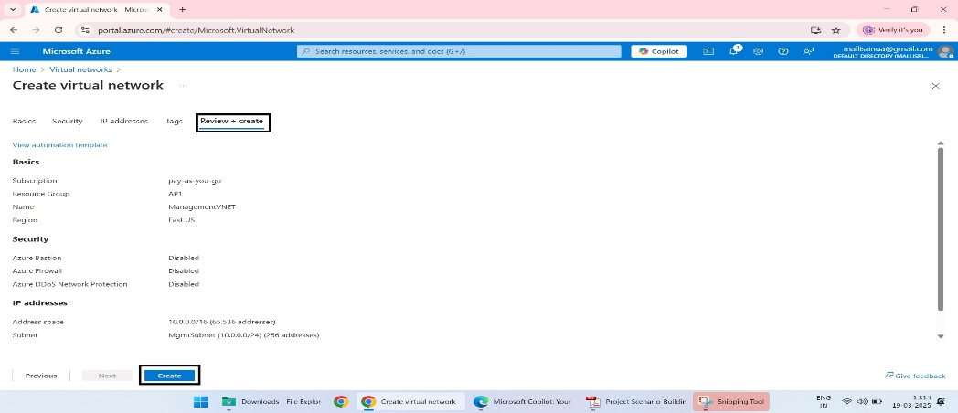

**Step 2: Configure VNET Peering from VM-VNet**

1. Navigate to **VM-VNet** in the Azure Portal.
2. Select **Peerings** from the left-hand menu.
3. Click **+ Add** to create a peering relationship.

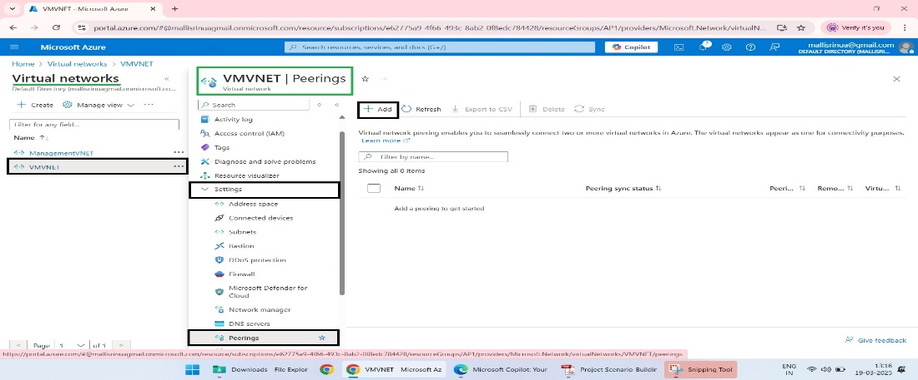

1. Fill out the details:
   * **Peering Link Name**: Peer-to-MgmtVNet.
   * **Remote Virtual Network**: Select Mgmt-VNet from the dropdown.
   * **Allow Virtual Network Access**: Enabled
   * **Allow Forwarded Traffic**: Disabled
   * **Allow Gateway Transit**: Disabled
   * Click **OK** to save the peering configuration.

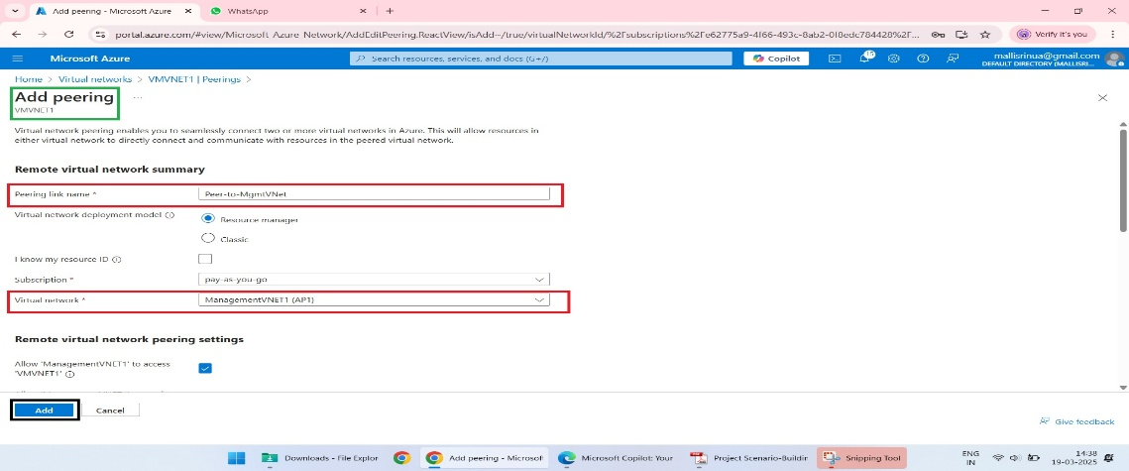

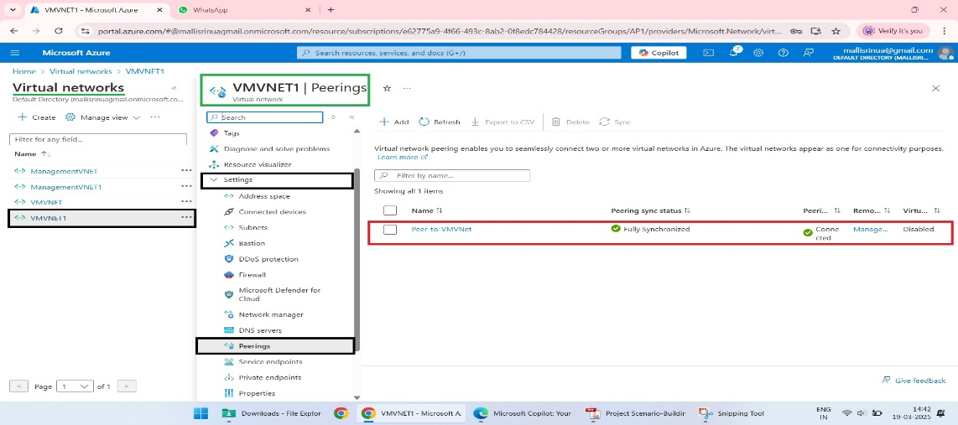

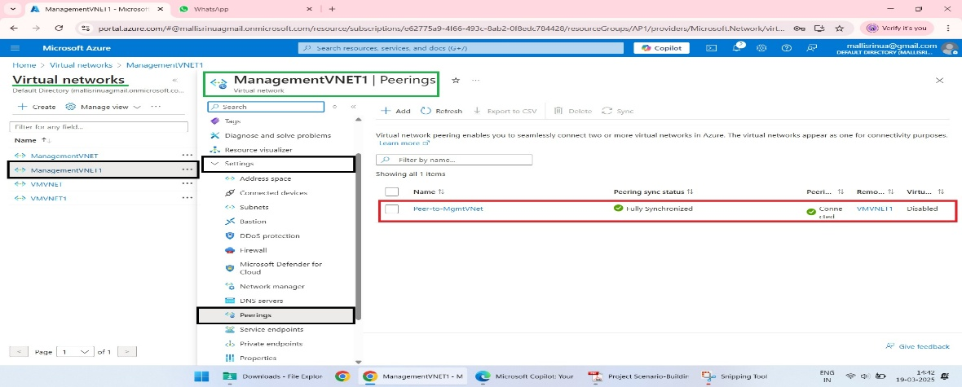

**Step 5: Test Secure Communication**

1. **Test Connectivity**:
   * Connect to one of the VMs using RDP
   * From this VM, run the following in the command prompt:cmd
   * ping <Private-IP-of-VM-in-other-VNet>
   * A successful ping indicates that VNET peering is functioning correctly.

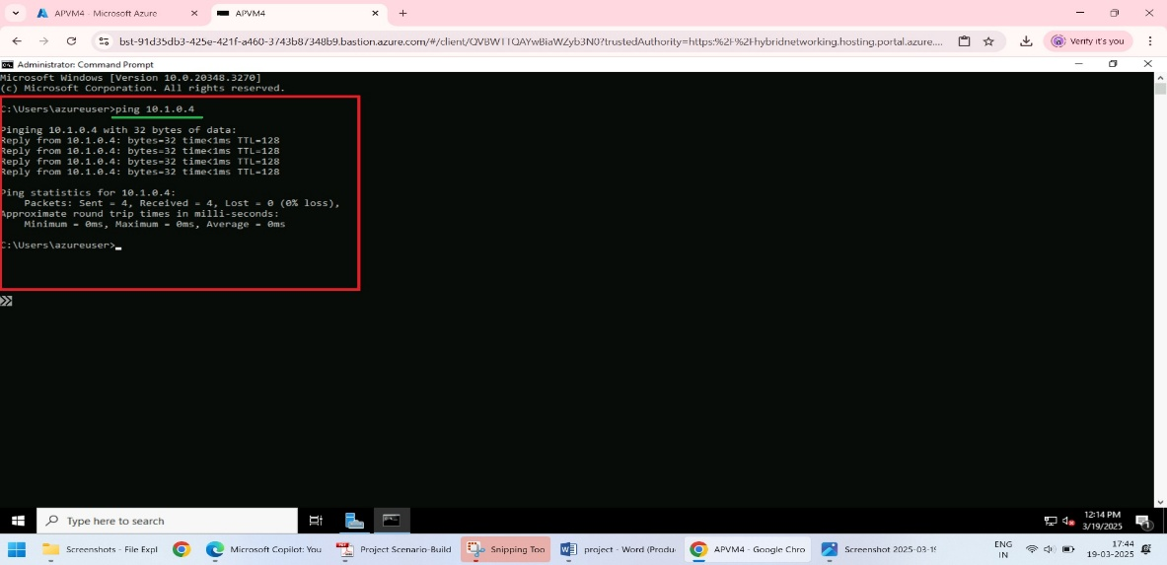

**Step 6: Configure Access to Management Resources**

1. **Set Up Azure Bastion**:
   * Deploy Azure Bastion in the Mgmt-Subnet:

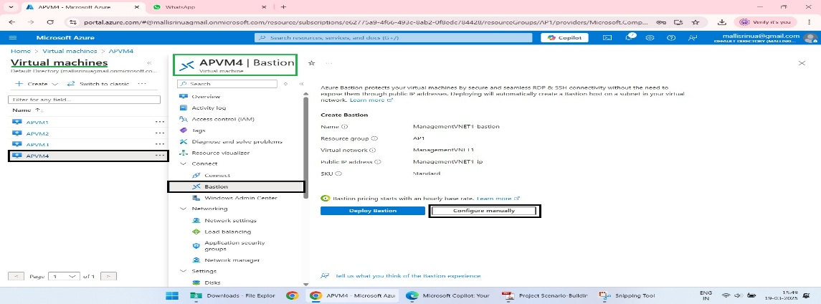

* + - Go to **Azure Bastion** > **+ Create**.
    - Assign it to Mgmt-VNet and select Mgmt-Subnet.

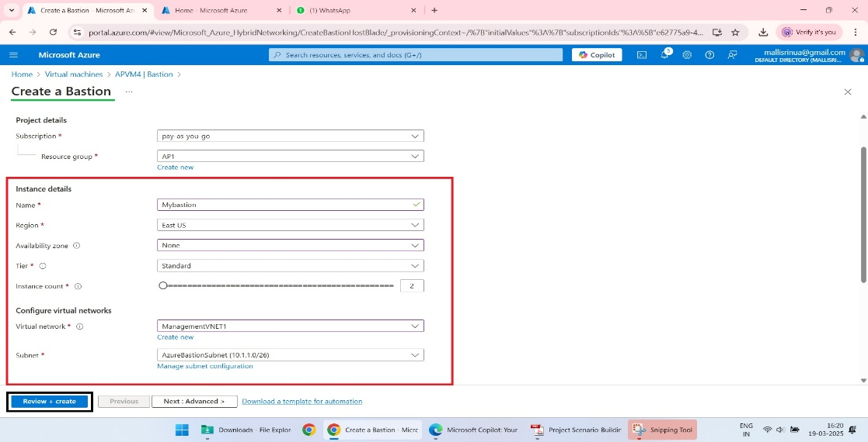

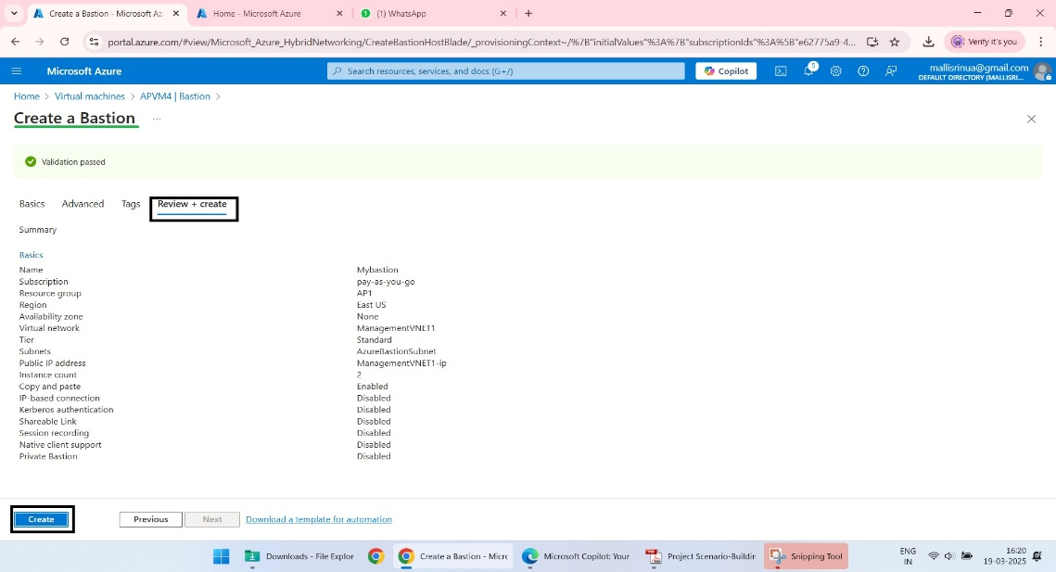

1. **Ensure NSG Rules Allow Required Traffic**:
   * For VM-Subnet NSG:
     + Allow inbound traffic from Mgmt-Subnet (IP range 10.1.1.0/24) to management ports (e.g., RDP/3389).

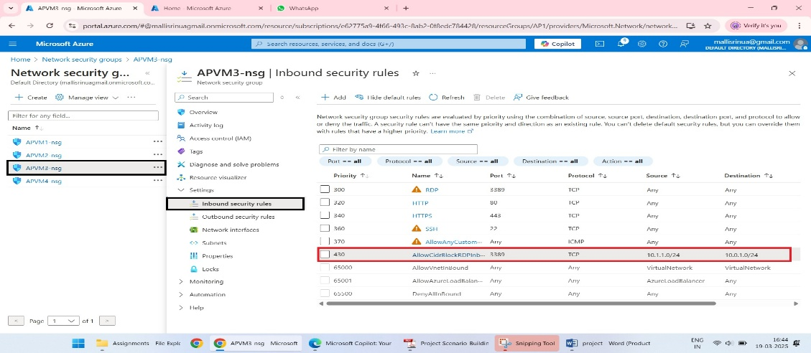

* + For Mgmt-Subnet NSG:
    - Allow inbound traffic from VM-Subnet (IP range 10.0.1.0/24) for necessary communication.

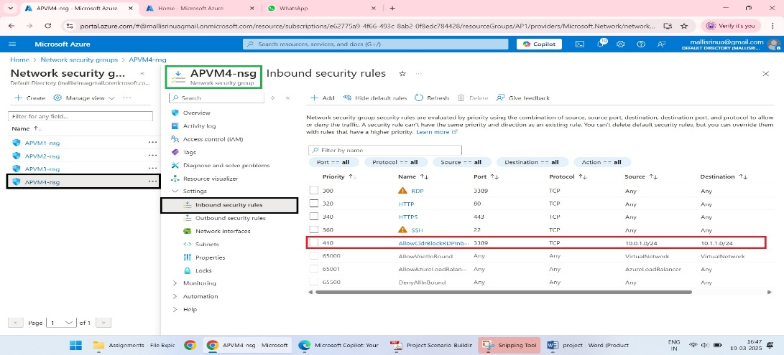

**3.verification**

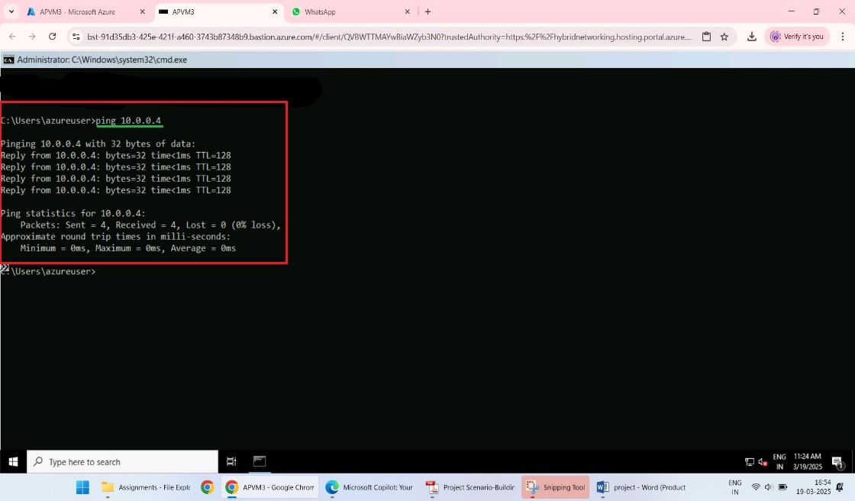

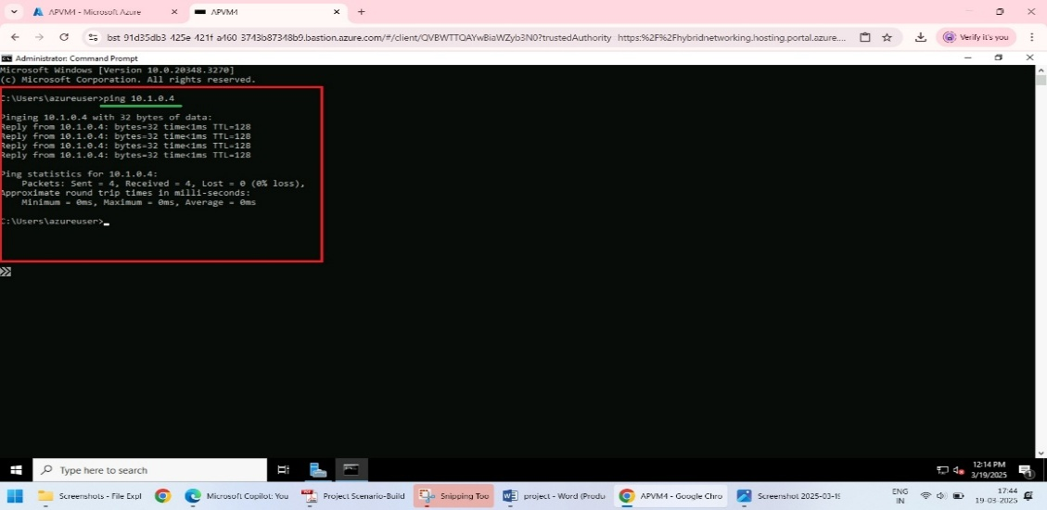

**6.Static Website Configuration:**

**Step 1: Azure Storage Setup**

**1.Create a Storage Account:**

* Go to the Azure Portal > Search for Storage Accounts > Click + Create.

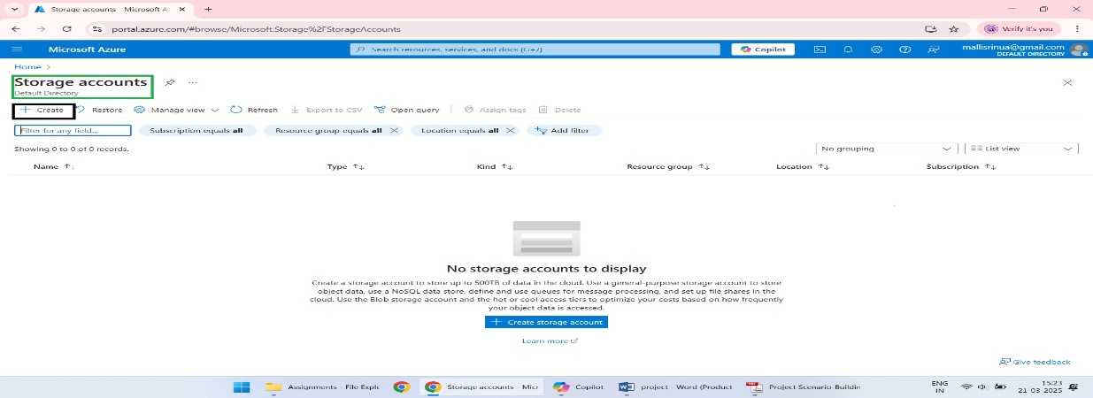

* Fill the needed details to create a storage account.

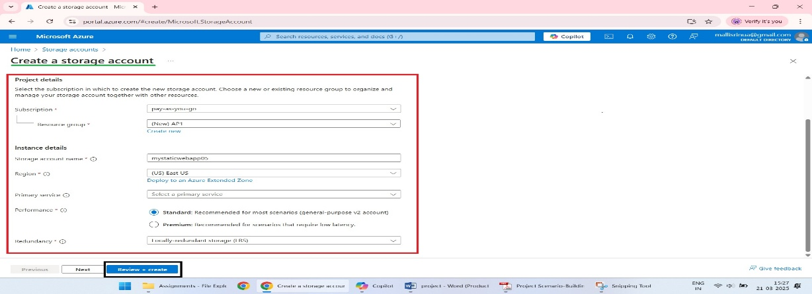

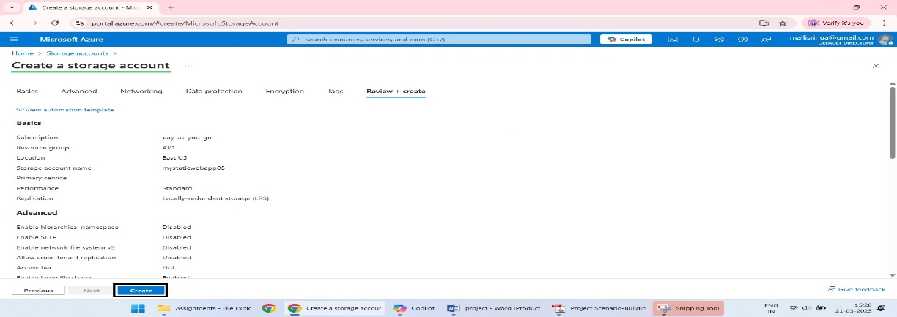

**2.Enable Static Website Feature:**

* Navigate to the newly created storage account.
* In the left menu, select Static Website under the Data Management section.
* Click Enable Static Website.
* Set the following:

**Index document name : eg: index.html**

**Error document path: eg: error.html**

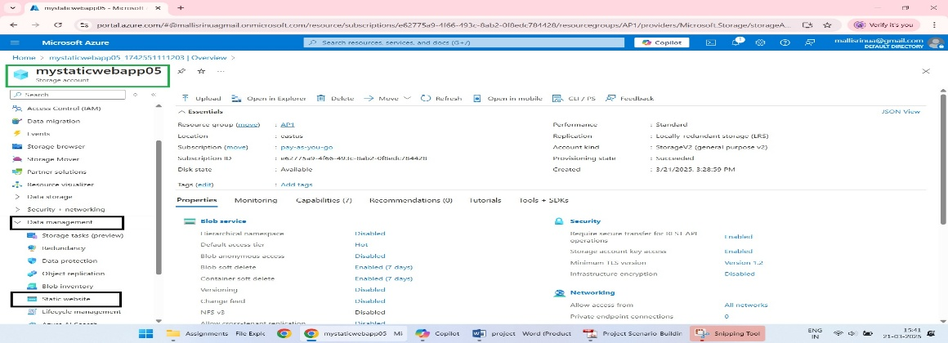

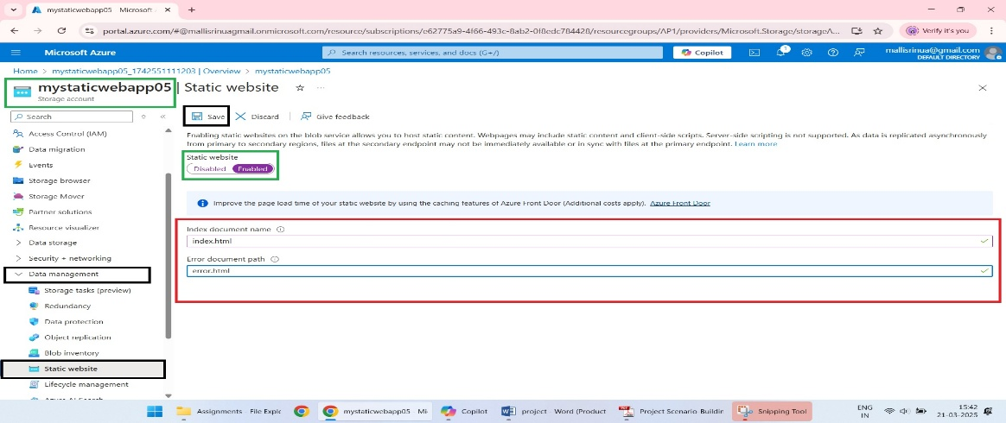

**Note: copy the primary endpoint.**

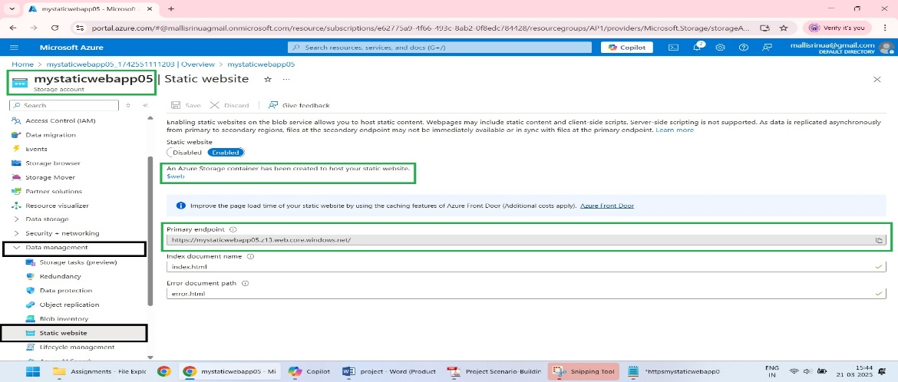

**Step 2: Upload Static Files:**

1.Navigate to the $web Container:

* After enabling the static website feature, Azure creates a special container named $web in the storage account.
* Go to the Containers section in the storage account > Select $web.

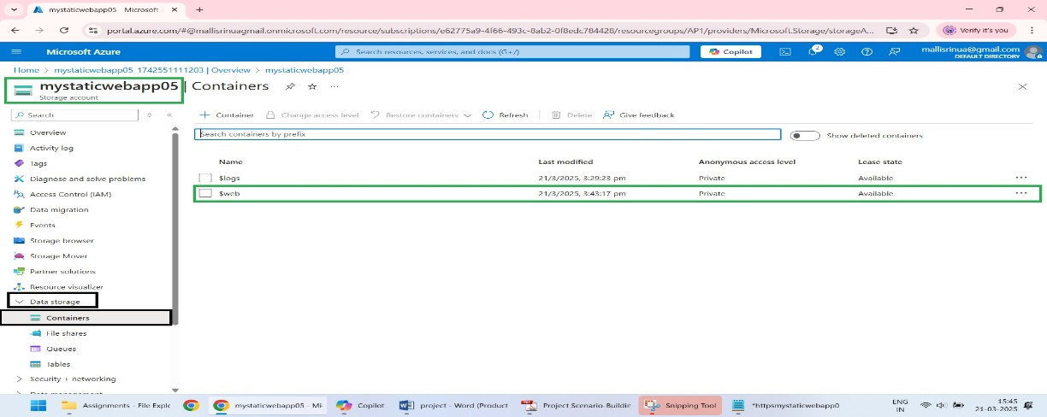

2.Upload Your Files:

* Click Upload and add your static files:

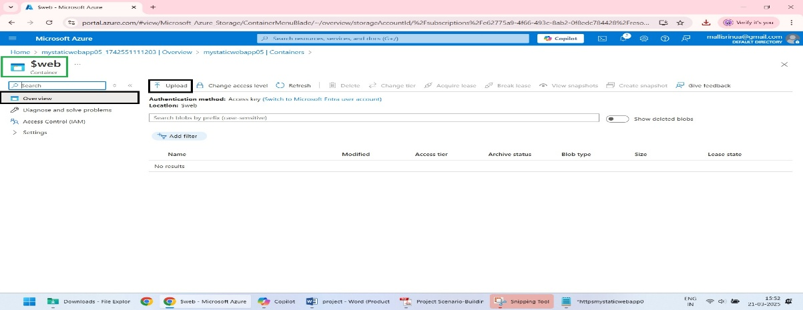

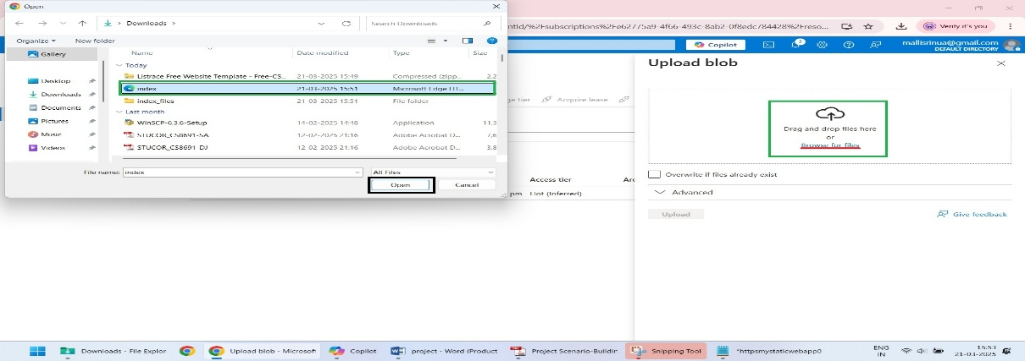

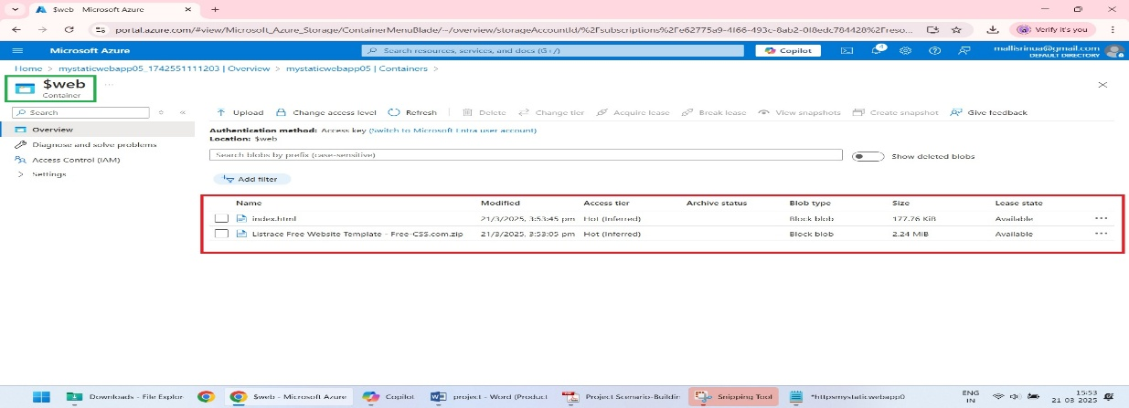

**3.Verify File Accessibility:**

* Once uploaded, note the Static Website URL displayed in the Static Website section
* Test by opening the URL in a browser to confirm the static website is live.

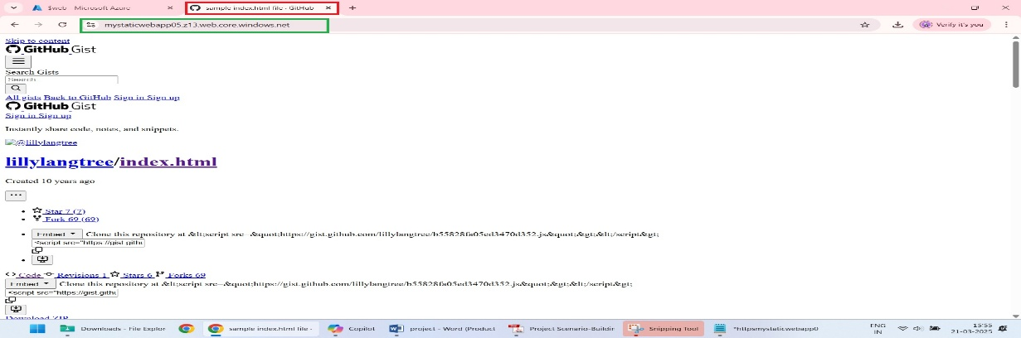

**Step 3: Custom Domain Configuration**

**1.Purchase a Domain Name:**

* If you don’t have one, purchase a domain from a registrar like Go Daddy.

**2.Map Custom Domain to Static Website:**

* Go to the Custom Domains section and add custom domain name.

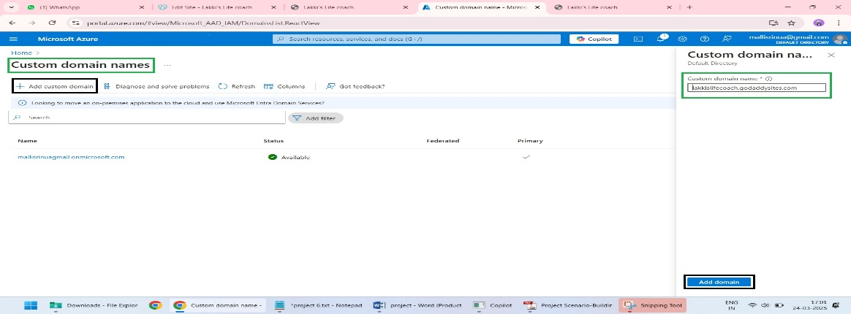

* Add the TXT record provided by Azure to your domain’s DNS settings using your registrar’s DNS management tools.

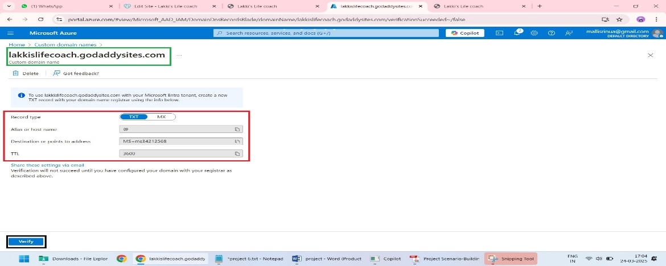

**3.Verify Domain Setup:**

* Wait for DNS propagation (can take up to 48 hours).
* Access your website using the custom domain to confirm it works.

